VAAGDEVI COLLEGE OF ENGINEERING
AUTONOMOUS
Bollikunta, Warangal, Telangana
Date: 23/01/2023
Academic Year 2022-2023
S. No. | Date’s | Name of Tournament | Name of Organization | No. Of Students Participation
1 | Dec-14-2022 | All India Inter University. Taekwondo Championship | JNTU | 01
2 | Nov-20-2022 | All India Inter University Archery Champion Ship- | JNTU | 01
3 | Nov-23-2022 | JNTU Inter University-Volley ball Champion ship- | JNTU | 03
4 | Dec-16-2022 | JNTU Inter University-Kho-Kho Champion ship-2022 | JNTU Kukatpally | 03
5 | Nov-15-2022 | Jyothishmathi Inter Collegegiate Volley ball Tournament. KARIMNAGAR | JITS | 10
6 | June-06-2023 | KITS Singapure State Level Inter Collegiate Fest – Volleyball Tournament | KITS(S) | 10
7 | April-02-2023 | KITS Volleyball Tournament | KITS, Wgl | 10

Achievement’s:-
- Nikhil-CSE-Participated in All India Inter University Taekwondo Championship organised by Punjab University.
- Vyshnavi-Civil-All India Inter University Archery Champion ship Organized by Gurukaasi University Punjab.
- Mahender-EEE-Participated in South Zone Volley ball Champion ship Organized by SRM University Chennai.
- Steeva-CSE-Participated in South Zone Kho-Kho Champion ship Organized by JNTU Kakinada.
- Jyothishmathi Inter Collegegiate Volley ball Tournament Winners.
- KITS Singapure State Level Inter Collegiate Fest – Volleyball Tournament Runners.
- KITS Volleyball Tournament, Winners.

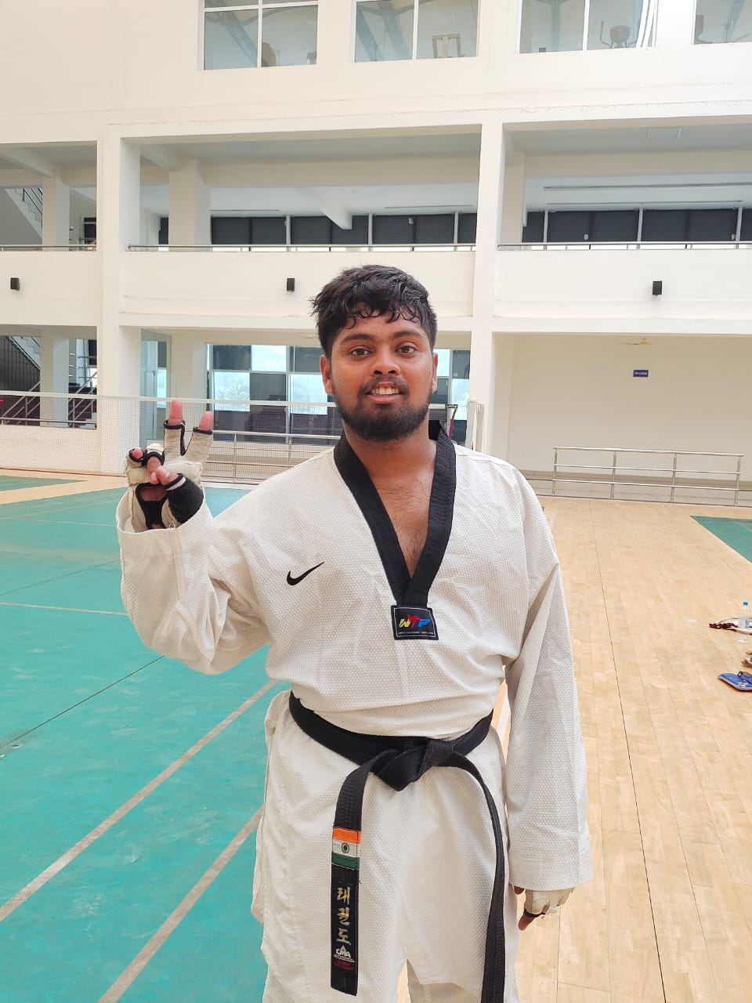
Nikhil-CSE-Participated in All India Inter University Taekwondo Championship organised by Punjab University, Dec-14-2022.

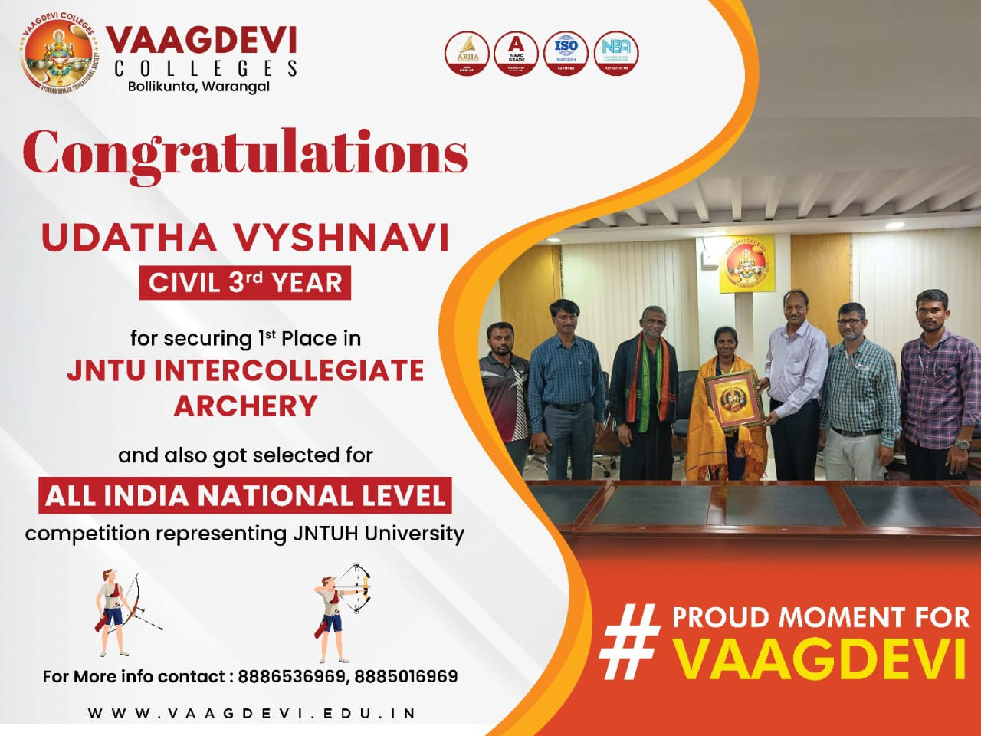

Vyshnavi-Civil-All India Inter University Archery Champion ship Organized by Gurukaasi University Punjab, Nov-20-2022.

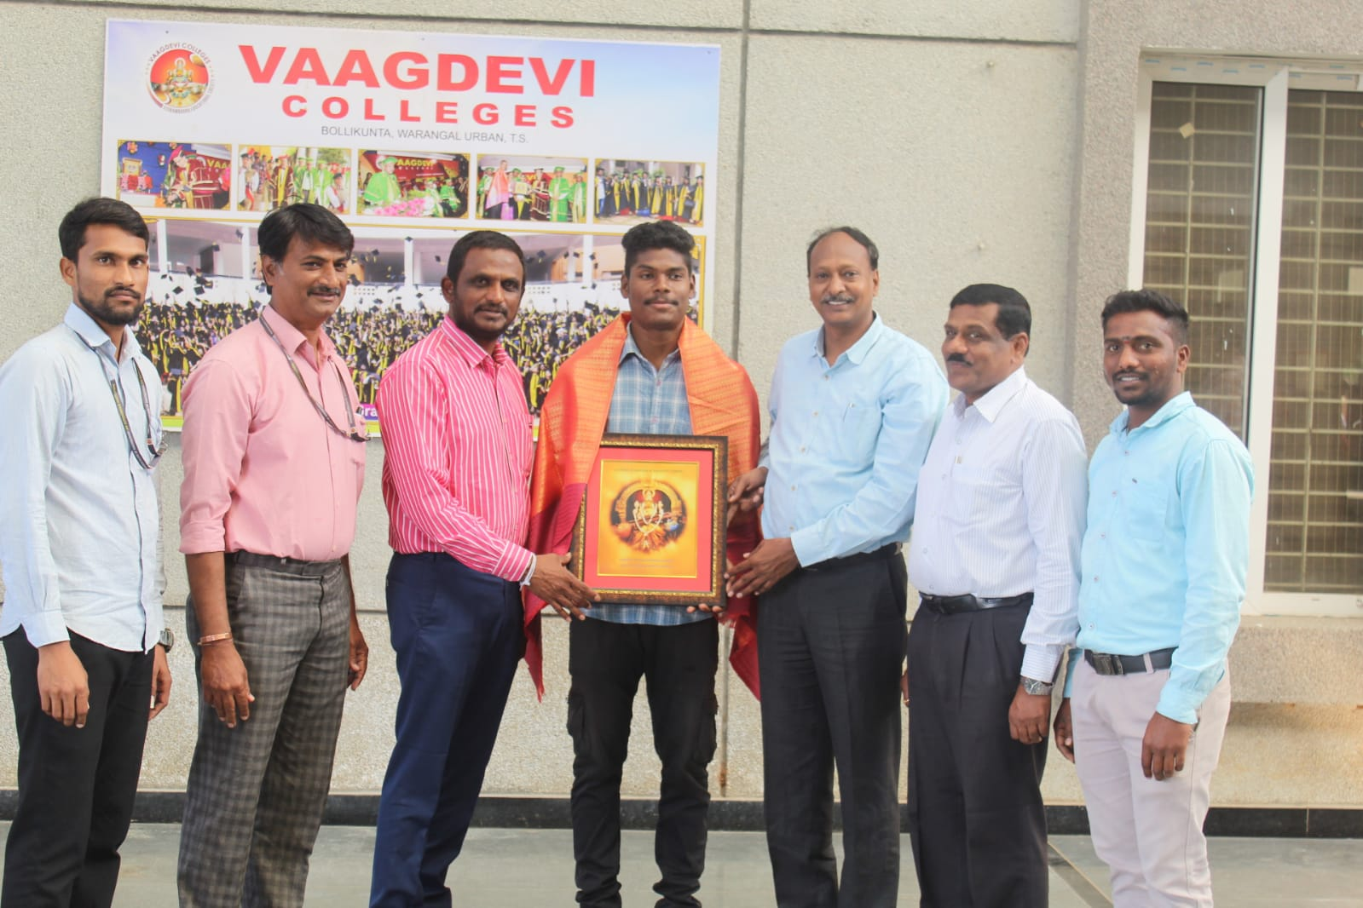
Mahender-EEE-Participated in South Zone Volley ball Champion ship Organized by SRM University Chennai, Nov-23-2022.
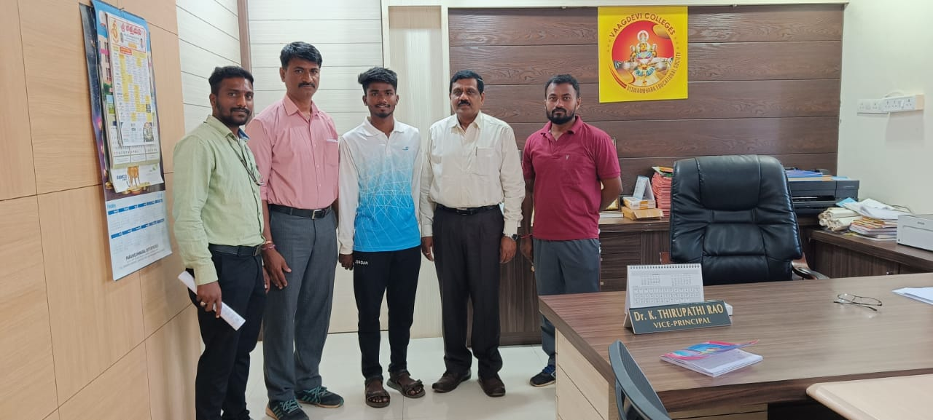

Steeva-CSE-Participated in South Zone Kho-Kho Champion ship Organized by JNTU Kakinada, Dec-16-2022.

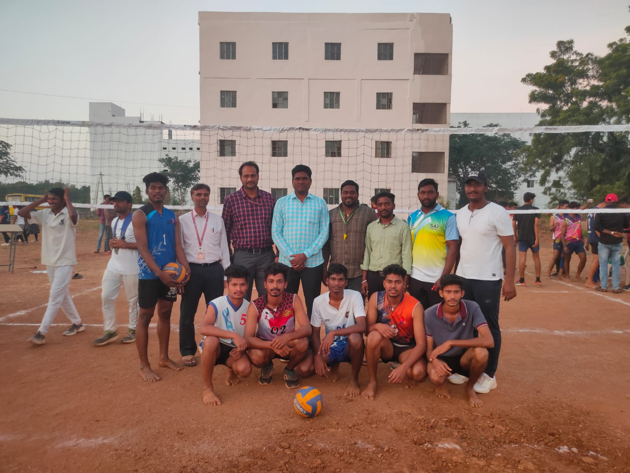

Jyothishmathi Inter Collegegiate Volley ball Tournament Winners.

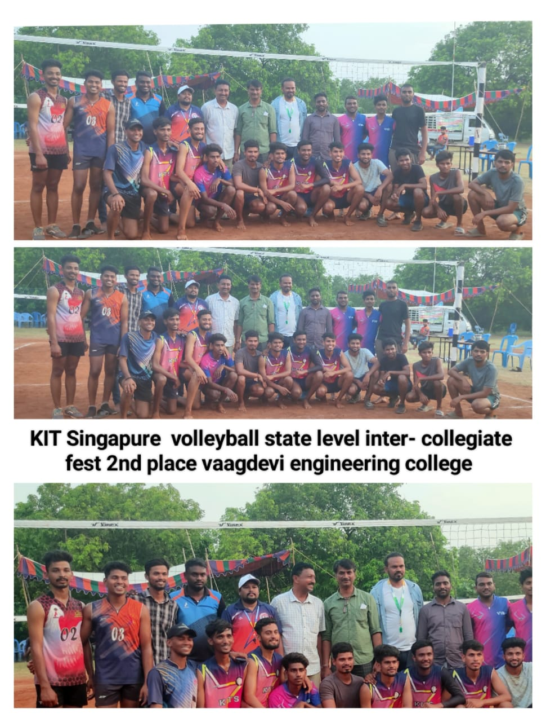
KITS Singapure State Level Inter Collegiate Fest – Volleyball Tournament Runners.
June-06-2023

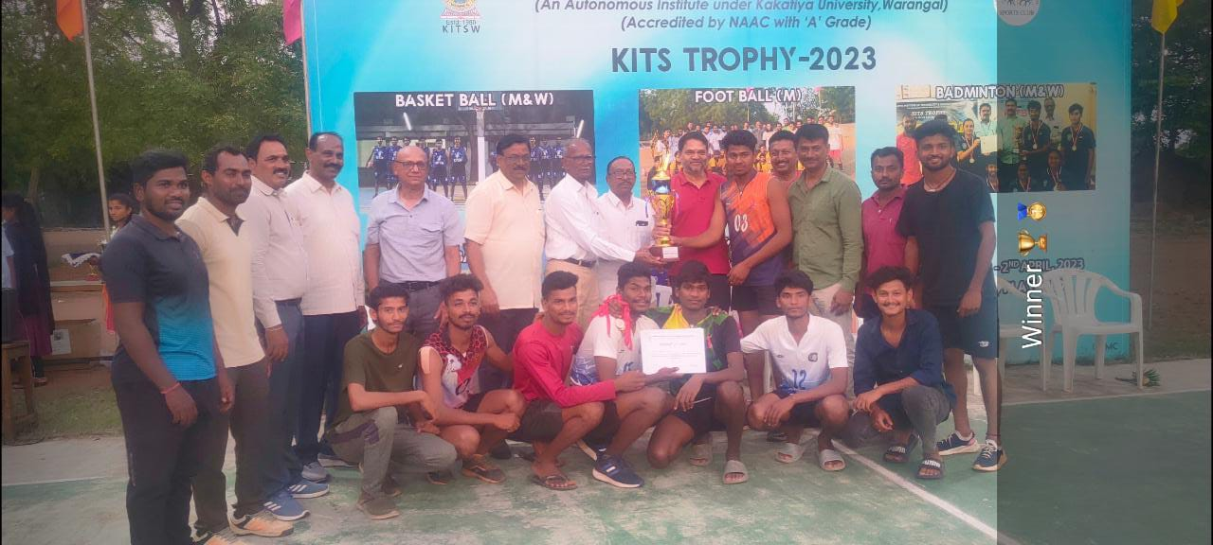

KITS Volleyball Tournament, Winners, April-02-2023

VAAGDEVI COLLEGE OF ENGINEERING
AUTONOMOUS
Bollikunta, Warangal, Telangana
Date: 28/04/2022
Academic Year 2021-2022
S. No. | Date’s | Name of Tournament | Name of Organization | No. Of Students Participation
1 | Feb-2022 | All Indian Inter University Boxing Champion Ship-2022 | LPU | 01
2 | Feb-2022 | All India Inter University Taekwondo Champion ship-2022 | JNTU | 01
3 | 30-March-2022 | Sakshi Premier league Cricket District Winners | Sakshi Press | 15
4 | March-2022 | SPL Zonal Runners | Sakshi Press | 15
5 | April-23-24 | Kits Trophy Volleyball Winners | Kits Warangal | 12
6 | April-23 | KITS Trophy Participated Bandminton, Kabaddi, Basketball | KITS, Warangal | 25
7 | Feb-2022 | JNTU Selections Batminton(girls), Football, Boxing, Taekwondo, Kabaddi, Yoga participated | JNTU Kukatpally | 08

Achievement’s:-
- Minhaz, Hussain – ECE (Roll No 18641A04E7), Prticipated All India Inter University Boxing Championship, Conducted by L.P.U. Punjab.
- Rishitha-Civil-Participated in All India Inter University Taekwondo Championship organised by Maharshi Dayanand University Rohtak Haryana.
- Sakshi Premier League (Cricket)-2022 District Winner’s.
- Sakshi Premier League (Cricket)-2022 Zonal Runners.
- Inter College Volley Ball Winner’s organized by KITS, Warangal.

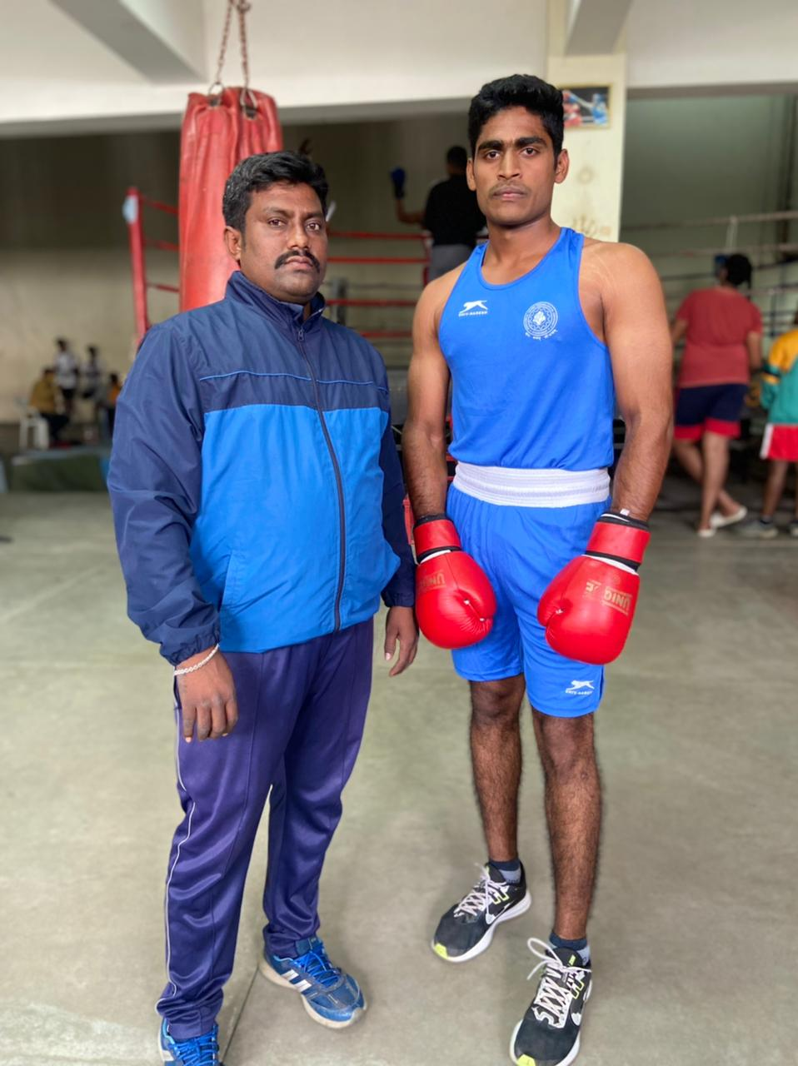
Minhaz, Hussain – ECE (Roll No 18641A04E7), Prticipated All India Inter University Boxing Championship, Conducted by L.P.U. Punjab, Feb-2022.
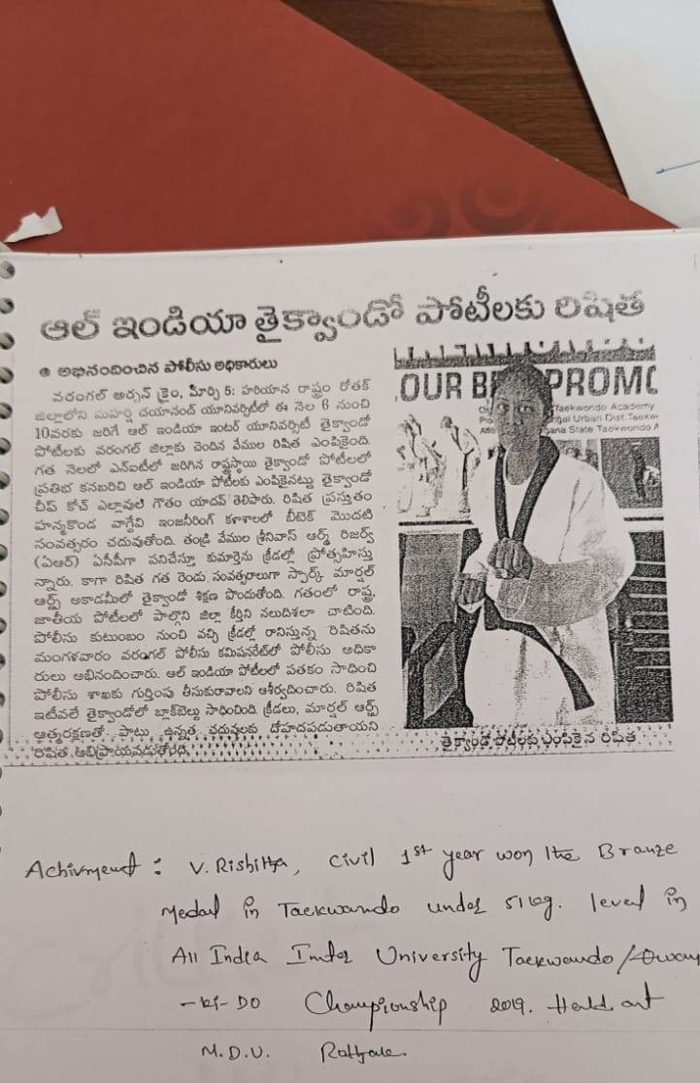
Rishitha-Civil-Participated in All India Inter University Taekwondo Championship organised by Maharshi Dayanand University Rohtak Haryana, Feb-2022.
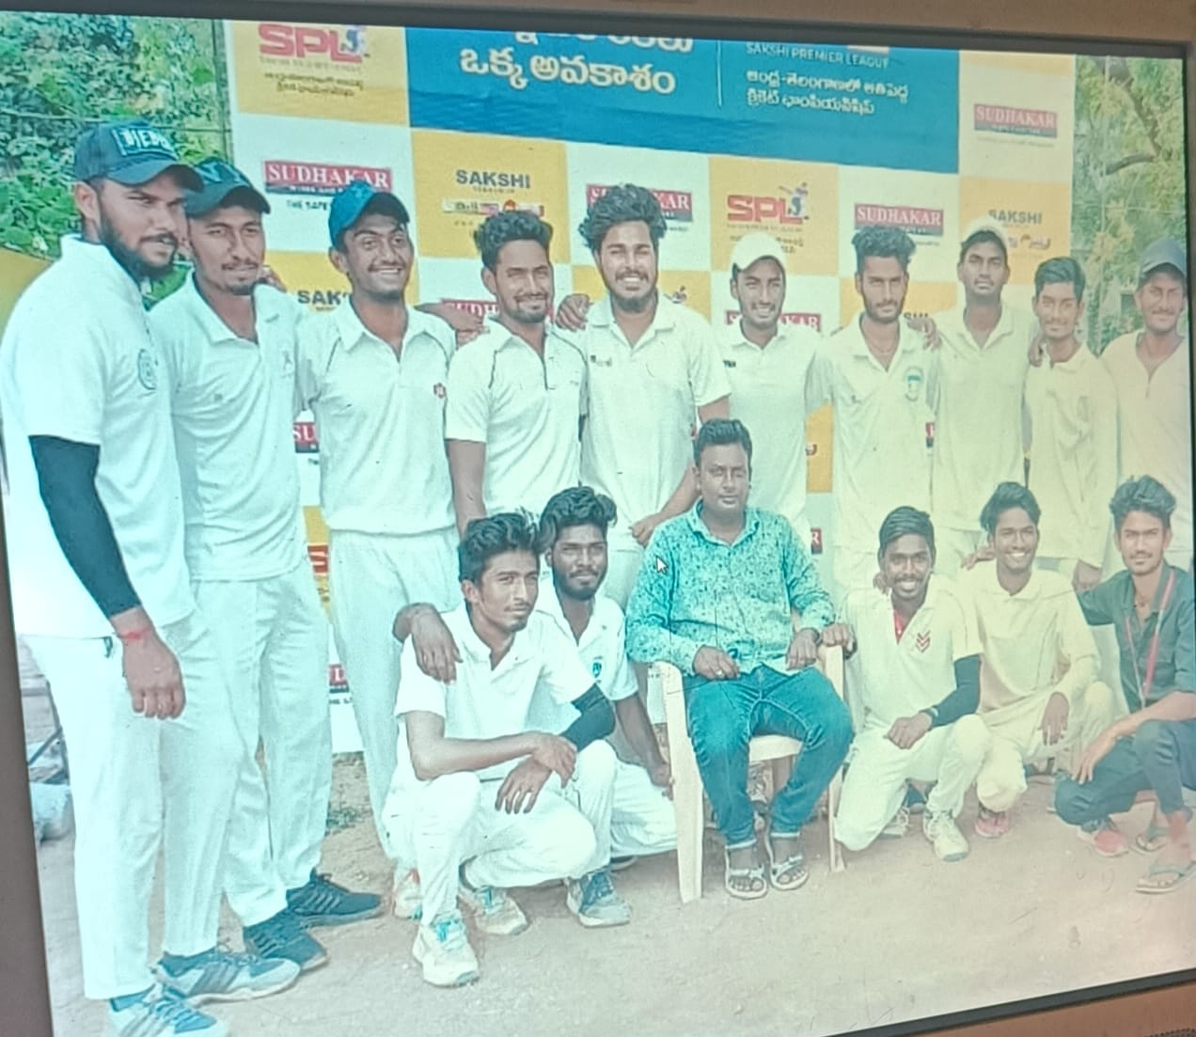

Sakshi Premier League (Cricket)-2022 District Winner’s, 30-March-2022.

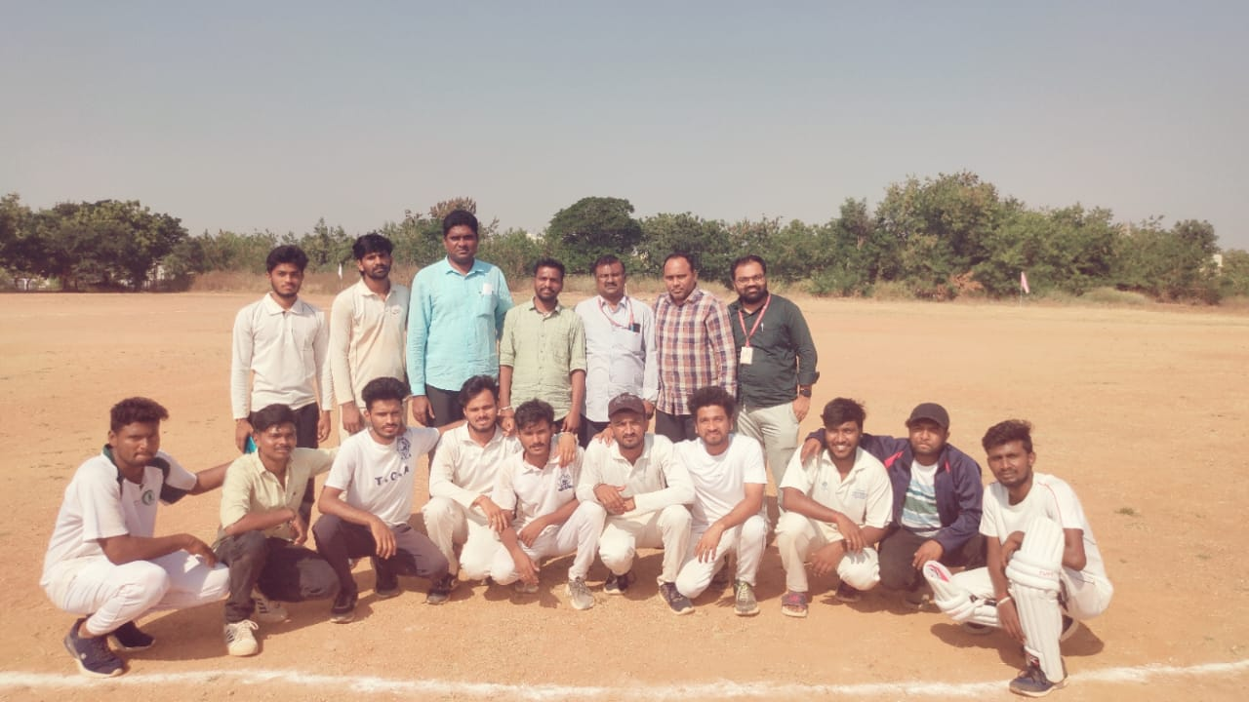
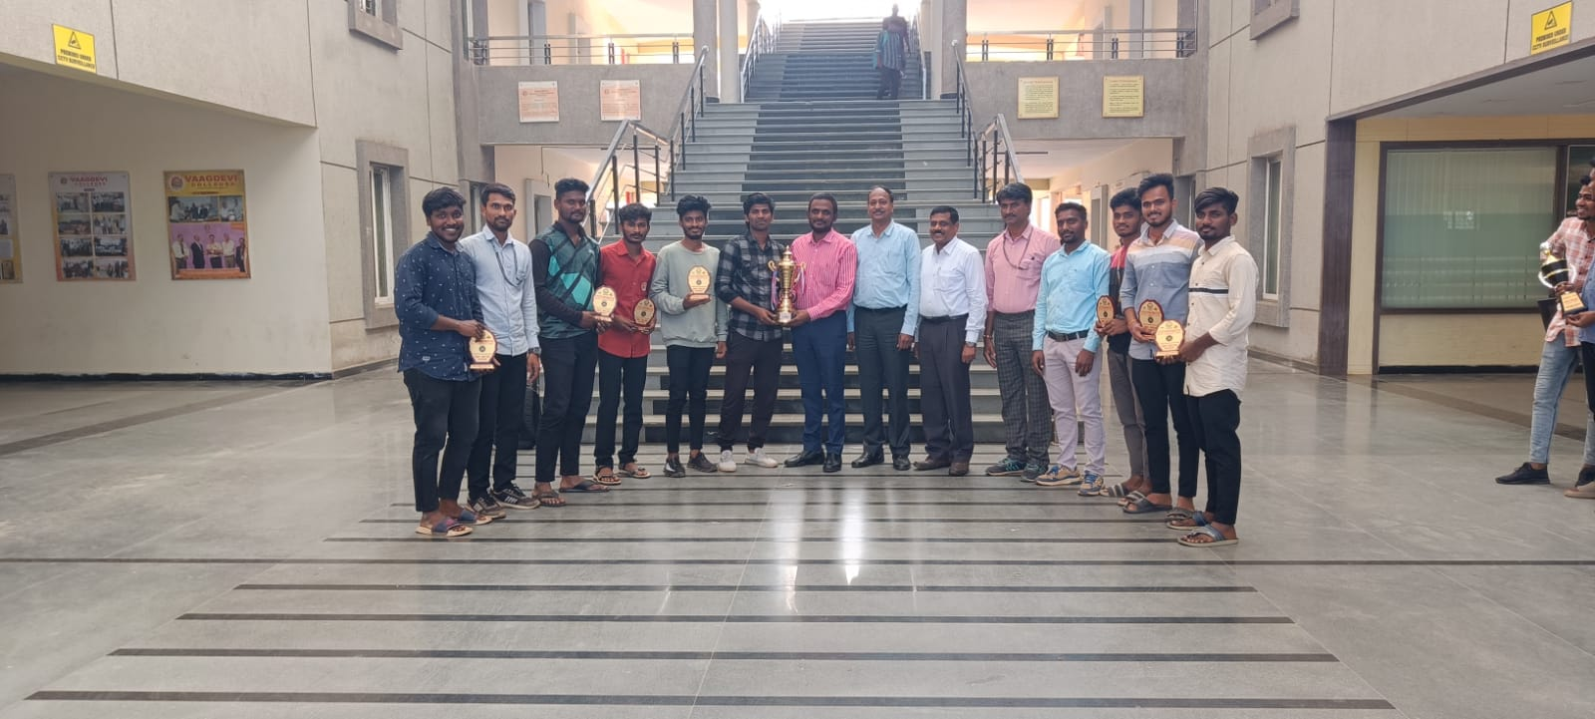
Sakshi Premier League (Cricket)-2022 Zonal Runners, March-2022, Vaagdevi College.

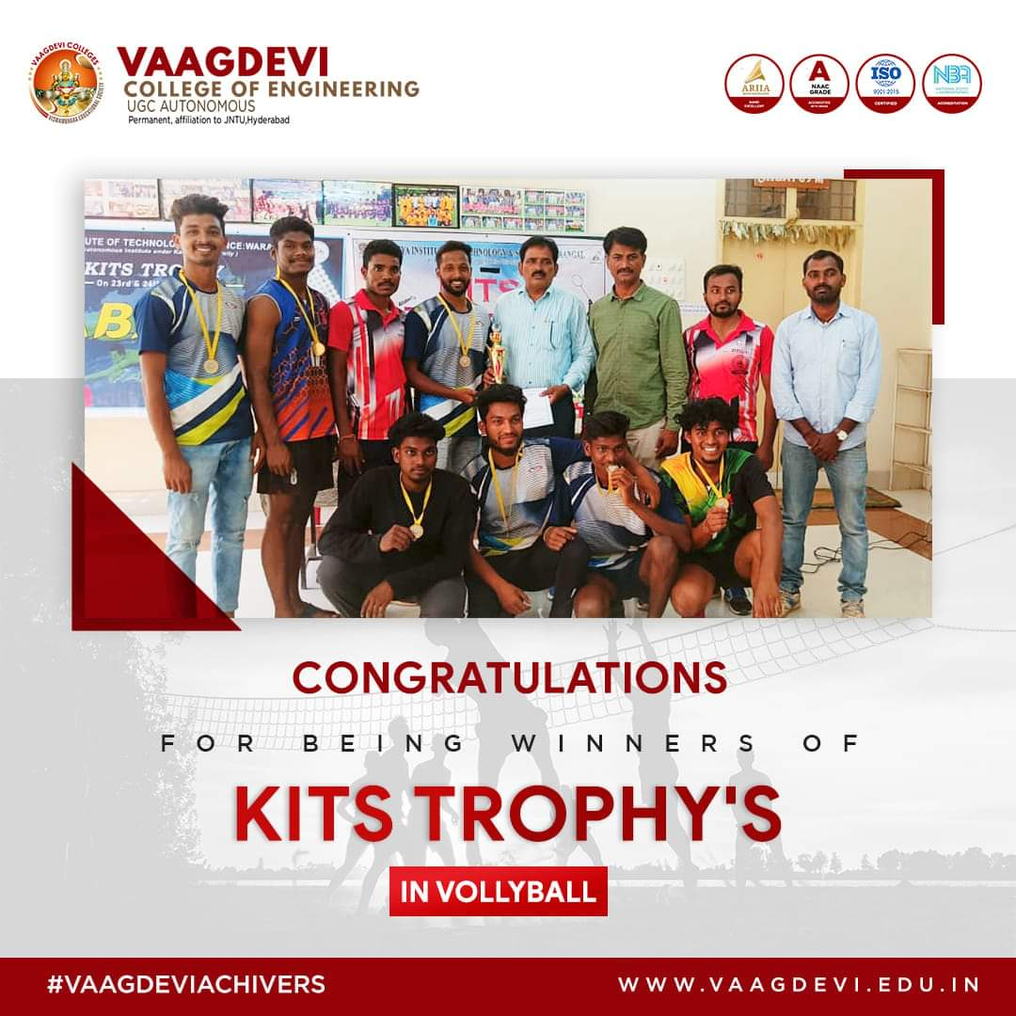
Inter College Volley Ball Winner’s organized by KITS, Warangal, April-23-24.

VAAGDEVI COLLEGE OF ENGINEERING
Games and Sports activities conducted/Participated in the college for the academic year 2019-20.
S. No. | Date’s | Name of Tournament | Name of Organization | No. Of Students Participation
01 | 20-09-2019 | Warangal Dist. Table Tennis Championship 2019 | WDTTA at KITS, Wgl. | 06
02 | 20-09-2019 | University Selections Kabaddi Women | JNTUH | 02
03 | 01-11-2019 | University Selections Kabaddi Men | JNTUH | 03

2019-20: Achievements:

- Mr. A. Sai Teja and Mr. O. Sharath played for State Level Badminton Championship 2020.
- Mr. P. Vivek also attended the Special National Integration Camp held at North East States
Cadet Senior Under Officer Mr. A. Abhilash have received Best Cadet Award for the year 2019-20.
- Mr. B. Madhu is selected in JNTU kabaddi team at Inter collegiate tournament 2019.
- Ms. Rishika got Bronze Medal in under 51kg in All India inter University TEKWONDO/Qwan-Ki-do Championship-2019. Held at Maharshi Dayanand University.
Rothak.
- Mr. Syed Muzeem has participated in “1st Invitational All India Helping Hands Martial Arts Open Online E-Kata Championship-2020” and won first prize prize in 50 weight category, Organized by Martial Arts Masters Helping Hands Welfare on 5th and 6th July 2020 at Kakinada.
- Mr. B. Aravind has won first prize for event Kick boxing under 6th RURAL GAME FEDERATION 2019-2020 held at Pune.
- Mr. Syed Muzeem has participated in Weapon Kata of brown belt and won second place at 3rd National Kung Fu Blood relation Championship-2019
- M. Vamshi Krishna has passed Shaolin Kung Fu at International Shaolin Kung Fu and promoted to yellow belt
- Mr. Minhaj Hussain Mohammed student of B.Tech-ECE won Gold Medal in all india interuniversity 75kgs boxing compititions in the year of 2019.
- Mr. Abrar Winner of State level Cricket Tournament Organized by Department of Physical Education and Sports, SR College of Engineering.
- Ch.Chandana received an award “Nruthya Rathna” from Nataraja Ramakrishna Smaraka Nruthyotsavam.
- Mr. A. Vamshi Krishna, B.Tech-EEE 4th Year student Won the 1st Place in Warangal District Table Tennis Championship, held at KITS
- Mr. Minhaz Hussain Md, B.Tech-ECE 2nd year students has participated in All India Inter University Boxing Tournament as a University team member.

2018-19: Achievements
- A.B.V.P Nypunya District level Sports & Cultural Events For Engineering students
MEN TEAM: Winners: Cricket .
- V. Rishitha, 1st Year Civil, won the Branze Medal in Taekwondo under 51 kg. level in All India Inter University Thaikwando / Qwan – Ki-Do championship 2019 held at M.D.U. Rohtak.

2017-18: Achievements:

- A.B.V.P Nypunya district level Sports & Cultural Events for Engineering students ,
MEN TEAM: Winners: Kabaddi, Chess, Carroms.
Runners: Volley ball,
WOMEN TEAM -Winners: Kabaddi,Throw ball, Kho-kho, 2017-2018 and 2018-19

2015-16: Achievements:
- Won the first prize in Basketball (Men) in Naipunya (ABVP & Vaagdevi College of Engineering) Inter collegiate Basketball tournament for men on 28th Sept, 2015.

- Won the Second prize in Throw Ball (Women) in Naipunya (ABVP & Vaagdevi College of Engineering) Inter collegiate Throw Ball tournament for Women on 22nd Sept, 2015.

2014-15: Achievements:
- Won the first prize in Basketball (Men) in Naipunya (ABVP & Vaagdevi College of Engineering) Inter collegiate Basketball tournament for men on 28th Sept, 2015.

- Won the Second prize in Throw Ball (Women) in Naipunya (ABVP & Vaagdevi College of Engineering) Inter collegiate Throw Ball tournament for Women on 22nd Sept, 2015.
- Mr. K. Vineeth Krishna, II-CSE, selected as team member of JNTUH University Swimming Team for the year 2014-15.

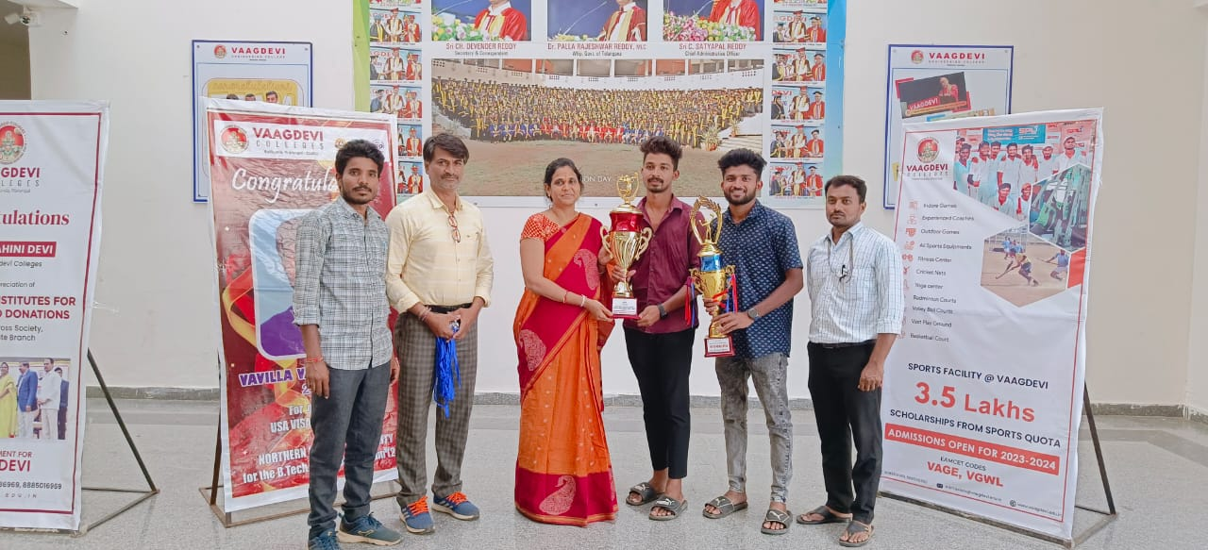

A. Vamshi Krishna, EEE 4th Year won the 1st place in Warangal district Table tennis Championship. Held at KITSW, 20-09-2019.

VAAGDEVI COLLEGE OF ENGINEERING VAAG KREEDA - 2023

MIXED DOUBLE – BADMINTON
- Winner’s  - Runners’s | - P. Steeva & Pallavi  - Nikhil & Sathvika | - CSE  - CSE
WOMEN SINGLE’S – BADMINTON
- Winner’s | - V. Chaithanya | - CSE IV Year
- Runners’s | - T. Pallavi | - BSH I Year

WOMEN DOUBLE’S - BADMINTON
- Winner’s - V. Chaithanya & Ch. Sathvika - CSE IV Year
- Runners’s - T. Pallavi & T. Akshaya - BSH(CSM) I Year

MEN SINGLE’S – BADMINTON
- Winner’s  - Runners’s | - B. Kaarthikeya  - P. Steeva | - CSE  - CSE IV Year
MEN DOUBLE’S – BADMINTON
- Winner’s | - Aravind & Akhula | - CIVIL
- Runners’s | - P. Steeva & Nikhil | - CSE IV Year
MIXED DOUBLE – CARROM
- Winner’s | - N. Varshini & T. Rishith | - ECE
- Runners’s | - Md. Sohel & Tejashwini | - EEE
WOMEN SINGLE’S – CARROM
- Winner’s | - Ramya | - ECE III Year
- Runners’s | - Mounika | - CSE III Year
WOMEN DOUBLE’S - CARROM
- Winner’s | - A. Varshitha & B. Yamini | - ECE IV Year
- Runners’s | - G. Tejashwini & N. Archana | - ECE
MEN SINGLE’S – CARROM
- Winner’s | - N. Sidhartha | - CSE
- Runners’s | - B. Anil | - CIVIL
MEN DOUBLE’S – CARROM
- Winner’s | - Sohel & Vikas | - EEE
- Runners’s | - Dineesh & Thirumal | -
WOMEN CHESS  - Winner’s | - K. Deepika | - CSE II Year
- Runners’s | - A. Varshitha | - ECE II Year

MEN CHESS  - Winner’s | - N. Vikas | - CSM
- Runners’s | - B. Prashanth | - CSD
TENNIKOIT SINGLE’S  - Winner’s | - A. Varshitha | - ECE
- Runners’s | - . Revathi | - ECE
TENNIKOIT DOUBLES  - Winner’s | - A. Varshitha & K. Sandya | - ECE IV Year
- Runners’s | - T. Revathi & T. Pavani | - ECE
TABLE TENNIS DOUBLES
- Winner’s | - P. Steeva & Nikhil | - CSE
- Runners’s | - Akhil & Abhi | - ECE III Year

TABLE TENNIS SINGLE’S
- Winner’s - Umesh - ECE
- Runners’s - Akhil - ECE

SHOT PUT BOYS

ATHLETICS & THROWS

- 1st Place | – Aravind | – CIVIL
- 2nd Place | – G. Kalyan | - Mech.
- 3rd Place | – Hashwanth | – CSE II Year

SHOT PUT GIRLS

- 1st Place – P. Sai Keerthi – CSE
- 2nd Place – P. Sai Priya – CSE
- 3rd Place – Ch. Sathwika – CSE

JAVALIN THROW BOYS

- 1st Place – Sk. Rashith – CSD
- 2nd Place – G. Kalyan – Mech.
- 3rd Place – P. Ramchander – Mech.

JAVALIN THROW GIRLS

- 1st Place – P. Sai Priya – CSE
- 2nd Place – P. Sai Keerthi – CSE
- 3rd Place – Ch. Sathwika – CSE

DISCUSS THROW BOYS

- 1st Place – Bharath – CIVIL
- ^{2nd} Place – G. Kalyan – Mech.
- 3rd Place – Pramod – CIVIL

ATHLETICS & RUNS

RUNNING -100MTS BOYS

- 1st Place – G. Kalyan – Mech.
- 2nd Place – L. Venkatesh – Mech.
- 3rd Place – B. Pradeep – EEE

RUNNING -100MTS GIRLS

- 1st Place – Ch. Sathvika – CSE III Year
- 2nd Place – S. Kavyasri – CSE I Year
- 3rd Place – A. Sanjana – CSE III Year

RUNNING -200MTS BOYS

- 1st Place – G. Kalyan – Mech.
- 2nd Place – L. Venkatesh – Mech.
- 3rd Place – M. Arun – CIVIL

RUNNING -200MTS GIRLS

- 1st Place – P. Bhavya Sri – ECE I Year
- 2nd Place – S. Kavya Sri – CSM I Year
- 3rd Place – Sai Priya – CSE III Year

RUNNING -400MTS BOYS

- 1st Place – G. Kalyan – Mech.
- 2nd Place – L. Venkatesh – Mech.
- 3rd Place – Ravi – EEE

RUNNING -400MTS GIRLS

- 1st Place – P. Sai Priya – CSE
- 2nd Place – Ch. Sathwika – CSE
- 3rd Place – A. Sanjana – CSE

RUNNING -800MTS BOYS

- 1st Place – L. Venkatesh – Mech.
- 2nd Place – G. Kalyan – Mech.
- 3rd Place – J. Prashnath – CSE

RUNNING -800MTS Girls

- 1st Place – Sathwika – CSE.
- 2nd Place – Kavya sri – CSM
- 3rd Place – Bhavya Sri – ECE

RUNNING -1600MTS BOYS

- 1st Place – Prashanth – CSE
- 2nd Place – L. Venkatesh – Mech.
- 3rd Place – Manoj – CIVIL

ATHLETICS & JUMPS

LONG JUMP BOYS

- 1st Place – G. Kalyan – Mech.
- 2nd Place – M. Arun – CIVIL
- 3rd Place – L. Venkatesh – Mech.

LONG JUMP GIRLS

- 1st Place – P. Sai Priya – CSE
- 2nd Place – Ch. Sathwika – CSE
- 3rd Place – P. Sai Keerthi – CSE

 |  | GAMES (BOYS)
KABADDI  - Winner’s | - CIVIL | - Captain | - Dilip Kumar
- Runners’s | - EEE | - Captain | - B. Naveen
VOLLEYBALL  - Winner’s | - CIVIL | - Captain | - E. Bhanuprasad
- Runners’s | - Mech. | - Captain | - G. Kalyan Kumar
BASKETBALL  - Winner’s | - ECE | - Captain | - K. Likhith
- Runners’s | - CIVIL | - Captain | - K. Pentesh
KHO-KHO  - Winner’s | - CIVIL | - Captain | - Bharath
- Runners’s | - CSE | - Captain | - P. Steeva
CRICKET  - Winner’s | - CSE | - Captain | - P. Steeva
Runners’s | - CIVIL | - Captain | - T. Rakesh
 |  | GAMES (GIRLS)
KABADDI  - Winner’s | - EEE | - Captain | - Srinika
- Runners’s | - CIVIL | - Captain | - B. Kalyani
THROWBALL  - Winner’s | - CSE | - Captain | - Chaithanya
- Runners’s | - EEE | - Captain | - Athira
KHO-KHO  - Winner’s | - CSE | - Captain | - B. Soumya Sri
- Runners’s | - CIVIL | - Captain | - B. Pravalika

VAAG KREEDA SPORTS AND GAMES VOLUNTERIES

  - Spots and Game Secretary - P. Steeva (CSE)

  - Ajay(CIVIL)

  - Bharath (CIVIL)

  - Umesh (ECE)

  - L. Venkatesh (Mech.)

  - D. Arun Kumar (CIVIL)

  - G. Kalyan (Mech.)

  - Bhanuprasad (CIVIL)

  - A. Pavan (Mech.)

  - Mahender (EEE)

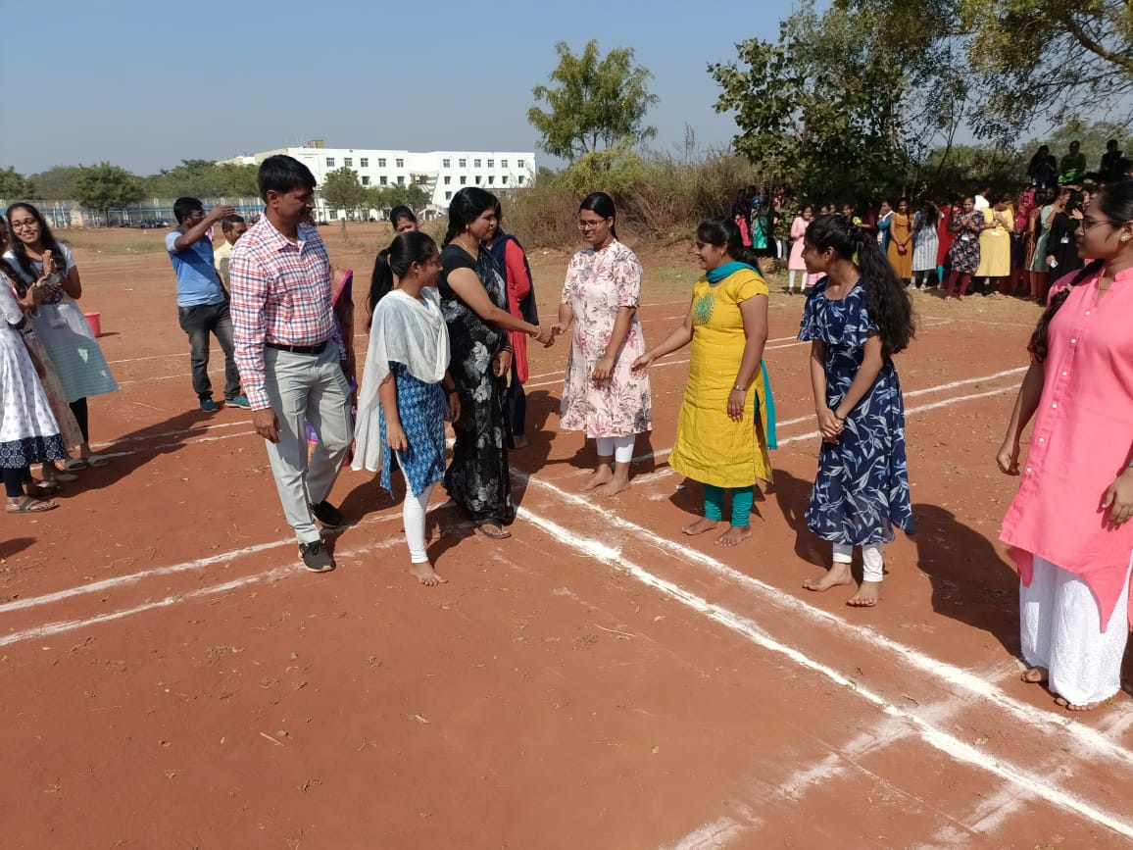
Intramural games April, 2023 Kho-Kho

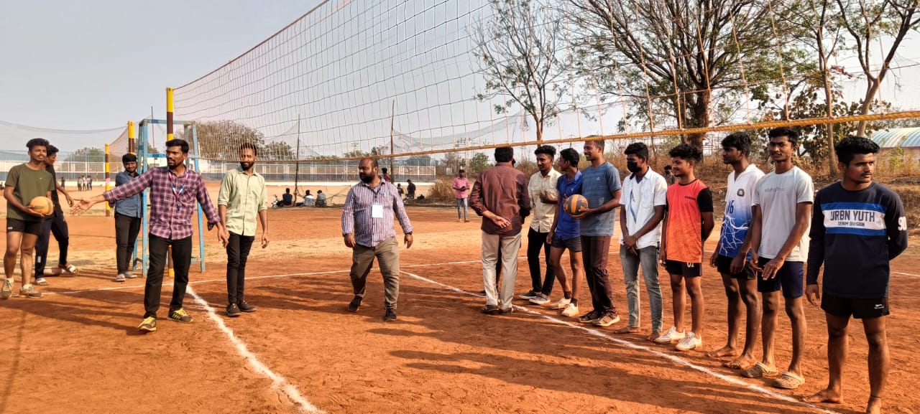
Intramural games April, 2023 Volleyball

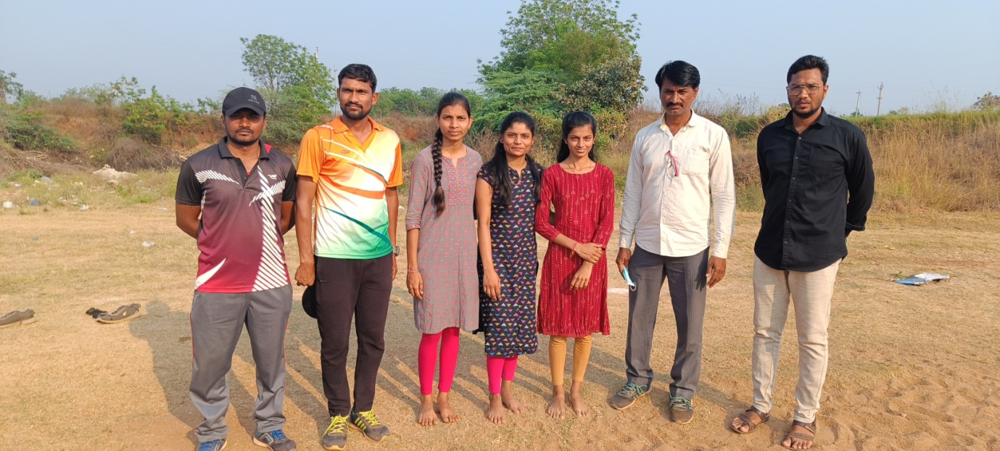
Intramural games April, 2023 Long Jump Girls, 1st , 2nd ,3rd Places

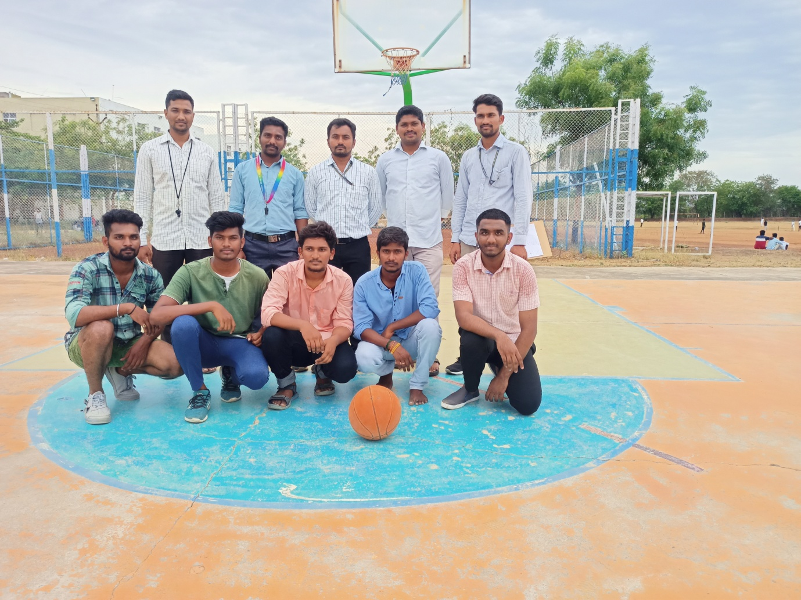
Intramural games 2023 Basket Ball

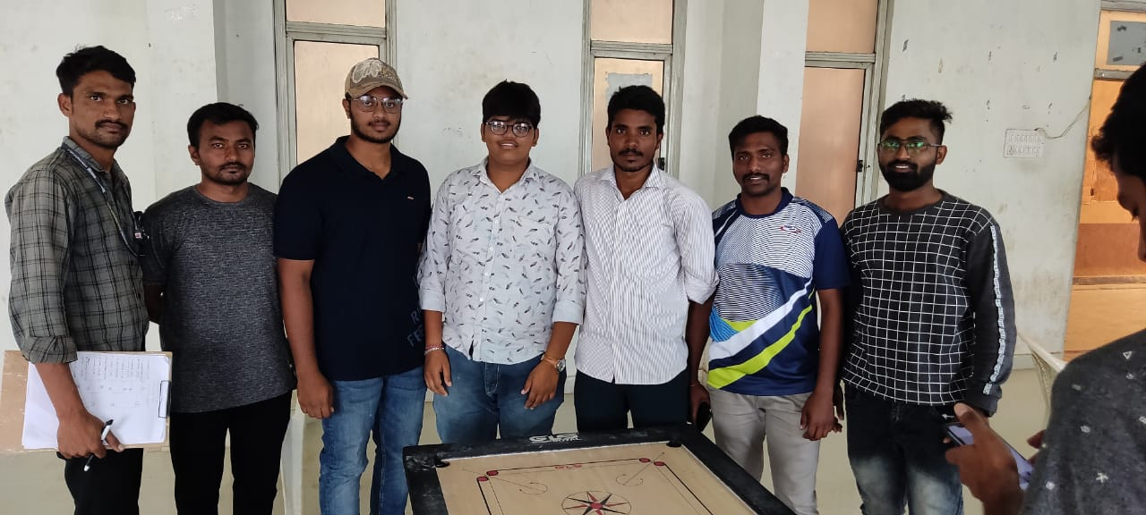
Intramural games 2023 Carrom, Boys

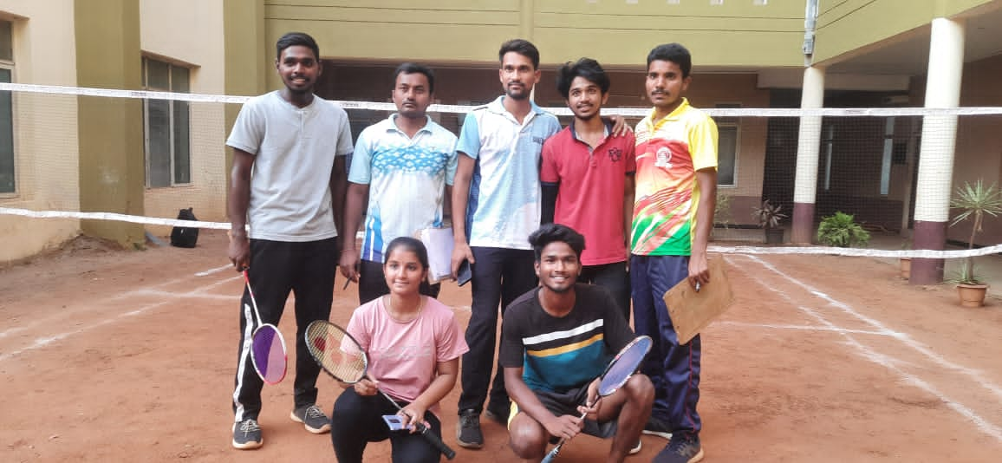
Intramural games 2023 Badminton, Mixed-Doubles

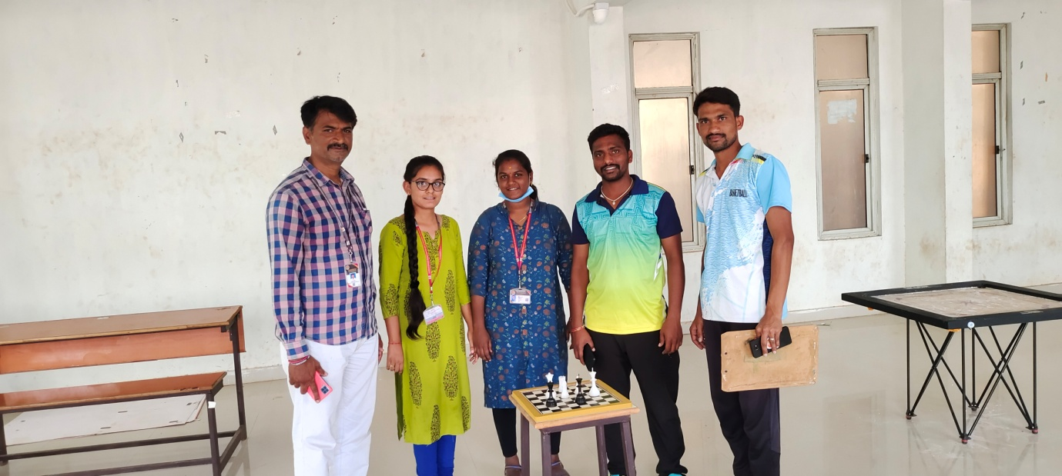
Intramural games 2023 Chess, Women
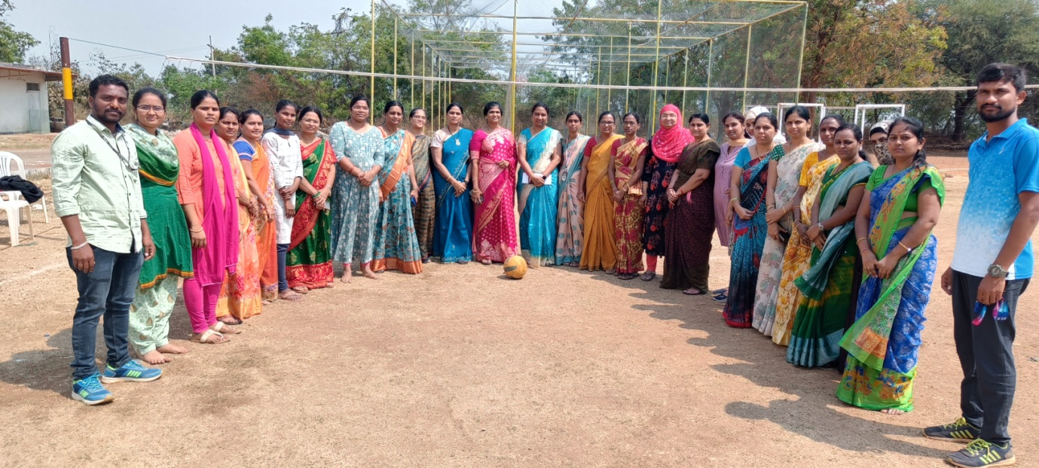
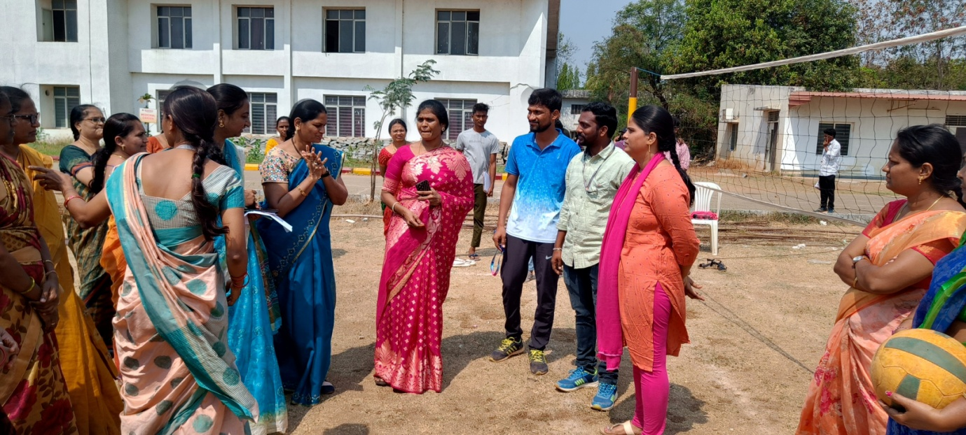
Intramural games 2023 Staff Throw Ball
VAAGDEVI COLLEGE OF ENGINEERING

VAAGKREEDA ‘2022’

RUNS
100 mtr Boys
3rd Place: N. Pavan Sai EEE
2nd Place: G. Nikhil CSE
1st Place: G. Kalyan MECH

100 mts GIRLS
3rd Place: B. Pravalika CIVIL
2nd Place: S. Athira EEE
1st Place: B. Swathi MECH
200 mts BOYS
3rd Place: P. Steeva CSE
2nd Place: Venkatesh MECH
1st Place: G. Kalyan MECH
200 mts GIRLS
3rd Place: M. Sravanthi CSE
2nd Place: Athira EEE
1st Place: P. Sai Priya CSE
400 mtr BOYS
3rd Place: Anil Nayak CIVIL
2nd Place: P. Steeva CSE
1st Place: Venkatesh MECH

400 mtr GIRLS
3rd Place: G. Pravalika EEE
2nd Place: G. Venkatesh EEE
1st Place: B. Swathi MECH
400 X 100 REALY
3rd Place: CIVIL
2nd Place: CSE
1st Place: MECHANICAL

VAAGDEVI COLLEGE OF ENGINEERING
VAAGKREEDA ‘2022’
THROWS
JAVELIN THROW BOYS:
3RD PLACE: T. ANIL NAYAK CIVIL
2ND PLACE: P. STEEVA CSE
1ST PLACE: S. SHISVJI EEE
JAVELIN THROW GIRLS:
3RD PLACE: D. AKHILA CIVIL
2ND PLACE: B. PRAVALIKA CIVIL
1ST PLACE: S. ATHIRA EEE
DISCUS THROW BOYS:
3RD PLACE: G. HARI KUMAR CIVIL
2ND PLACE: N. HARIHARAN CIVIL
1ST PLACE: K. YAGNESHWAR EEE
SHOTPUT GIRLS:
3RD PLACE: D. AKHILA CIVIL
2ND PLACE: B. PRAVALIKA CIVIL
1ST PLACE: S. ATHIRA EEE
SHOTPUT BOYS:
3RD PLACE: G. KALYAN MECH
2ND PLACE: S. SHIVAJI EEE
3RD PLACE: K. YAGNESHWAR EEE
LONGJUMP BOYS:
3RD PLACE: P. STEEVA CSE
2ND PLACE: G NIKHIL CSE
1ST PLACE: G. KALYAN KUMAR MECH
VAAGDEVI COLLEGE OF ENGINEERING
VAAGKREEDA ‘2022’

BADMINTON: SINGLES (BOYS)
RUNNERS: B. KARTHIKEYA CSE
WINNERS: G. NIKHIL CSE
BADMINTON: SINGLES (GIRLS)
RUNNERS: K. MANISHA CSE
WINNERS: V. CHAITHANYA CSE
BADMINTON: DOUBLES (MEN)
RUNNERS: SRINADH MECH
NITHIN MECH
WINNERS: G. NIKHIL CSE
P. STEEVA CSE
BADMINTON: DOUBLES (GIRLS)
RUNNERS: B. SOUMYA SRI CSE
CH. SATHVIKA CSE
WINNERS: V. CHAITHANYA CSE
B. NAVYA SRI CSE
BADMINTON: MIXED DOUBLES
RUNNERS: G. NIKHIL CSE
CH. SATHVIKA CSE
WINNERS: P. STEEVA CSE
V. CHAITHANYA CSE

VAAGDEVI COLLEGE OF ENGINEERING
VAAGKREEDA ‘2022’

CARROM: SINGLES: BOYS
RUNNER: G. THIRUPATHI REDDY CSE
WINNER: MD. SOHAL EEE
CARROM: SINGLES: GIRLS
RUNNER: K. SAISHMA CSE
WINNER: O. AKSHARA REDDY ECE
CARROM: DOUBLES: BOYS
RUNNERS: T. RITHISH
M. SHUSHANK ECE
WINNERS: G. VIKAS
CH. PAVAN EEE
CARROM: DOUBLES: GIRLS
RUNNERS: P. TEJASWINI
S. GAYATHRI ECE
WINNERS: CH. TEJASWINI
S. ATHIRA ECE
CHESS: BOYS
RUNNERS: V. VISHNU TEJA CSE
WINNERS: N. SRIHARSHA VIKAS CSM
CHESS: GIRLS
RUNNER: A. VARSHITHA ECE
WINNER: P. TEJASWINI ECE

VAAGDEVI COLLEGE OF ENGINEERING
VAAGKREEDA ‘2022’

VOLLEYBALL: BOYS
RUNNER: MECH
WINNER: ECE
THROW BALL: GIRLS
RUNNER: CSE
WINNER: CIVIL
KHO-KHO: BOYS
RUNNER: ECE
WINNER: CSE
KHO-KHO: GIRLS
RUNNER: ECE
WINNER: CSE
KABADDI: BOYS
RUNNER: EEE
WINNER: MECH
KABADDI: GIRLS
RUNNER: ECE
WINNER: CIVIL
CRICKET: BOYS
RUNNER: CIVIL
WINNER: EEE
Basket Ball: BOYS
RUNNER: CIVIL
WINNER: CSE
VAAGDEVI COLLEGE OF ENGINEERING
Bollikunta, Warangal, Telangana

- Game Secretary for boys: Md. Sameer – EEE
- Game secretary for girls: B. Pravalika – Civil
- Sports secretary for boys: Srinadh-mech
- Sports Secretary for girls: V. Chaithanya-CSE

- Cricket captain: Sai Kushal – Civil
- Kabaddi captain: Darmateja – Civil
- Volley ball Captain: Akshay – Mech
- Kho-Kho Captain: P. Steeva – CSE

Physical Director Department Of Physical Education Principal

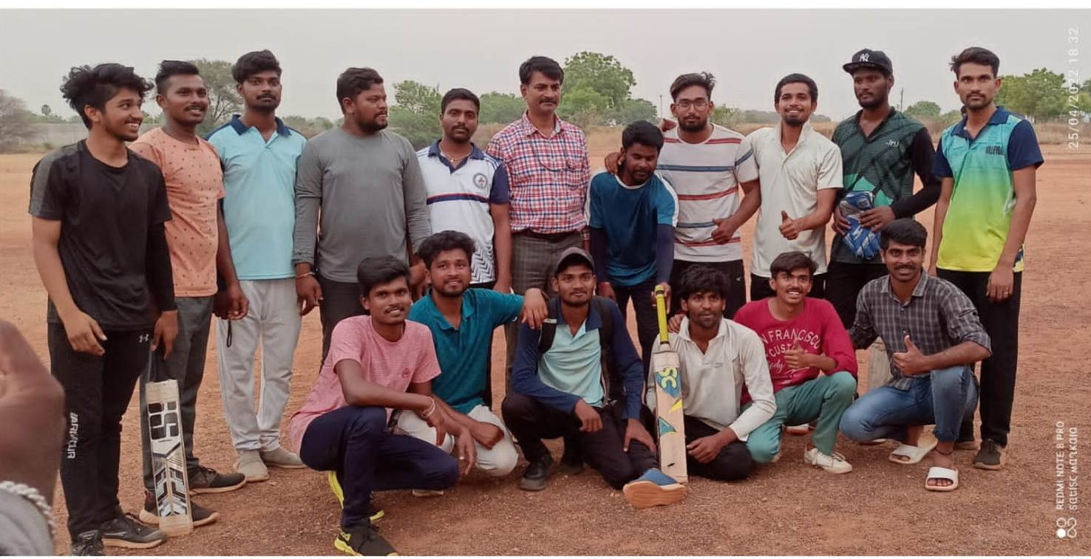

Intramural games April, 2022 Cricket

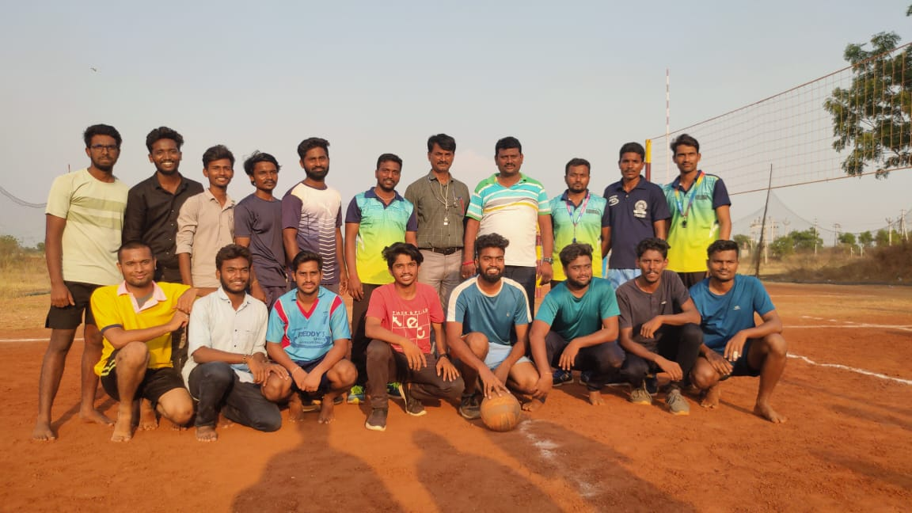
Intramural games April, 2022 Volley Ball

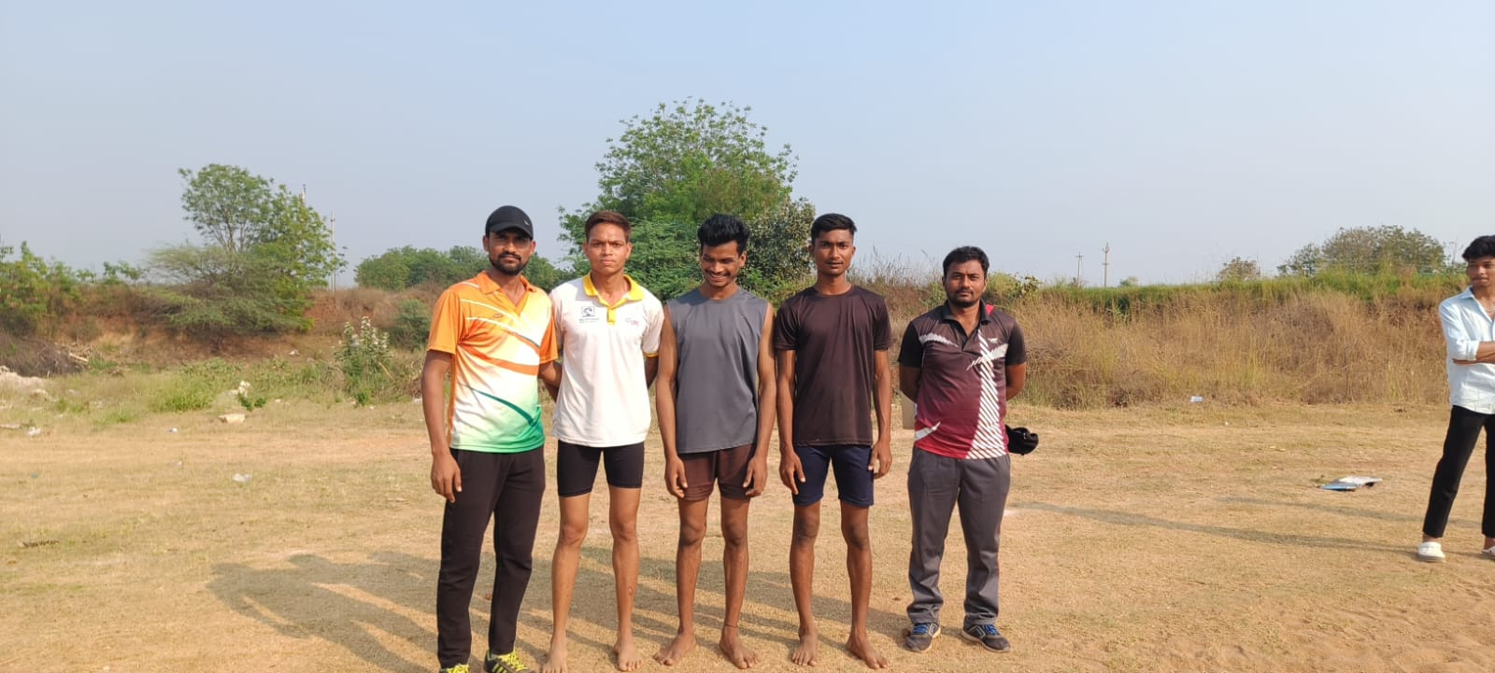
Intramural games April, 2022 Long Jump Boys, 1st , 2nd ,3rd Places
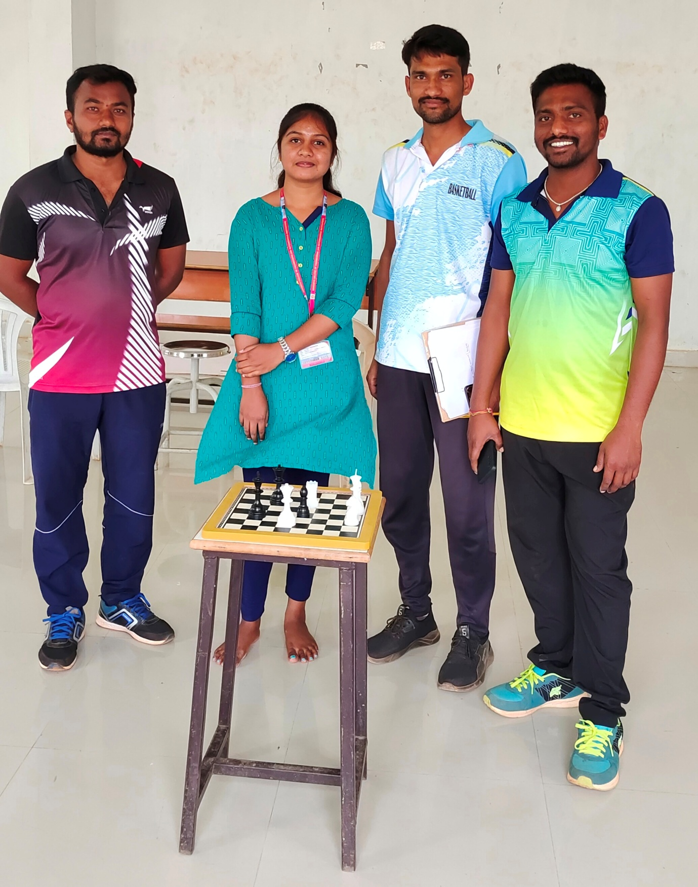
Intramural games April, 2022 Chess, Girls

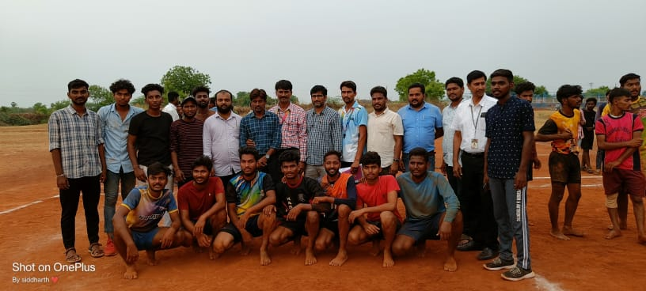
Intramural games April, 2022 Kabaddi

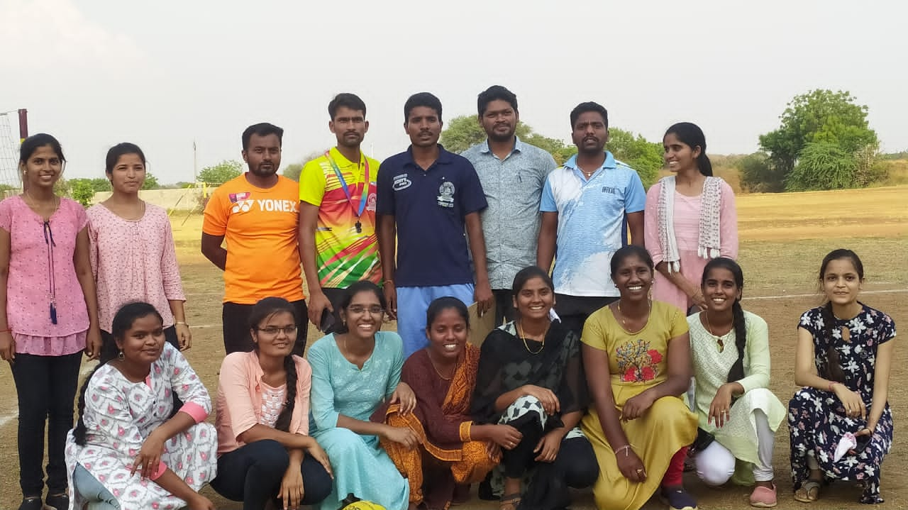

Intramural games April, 2022 Throw Ball

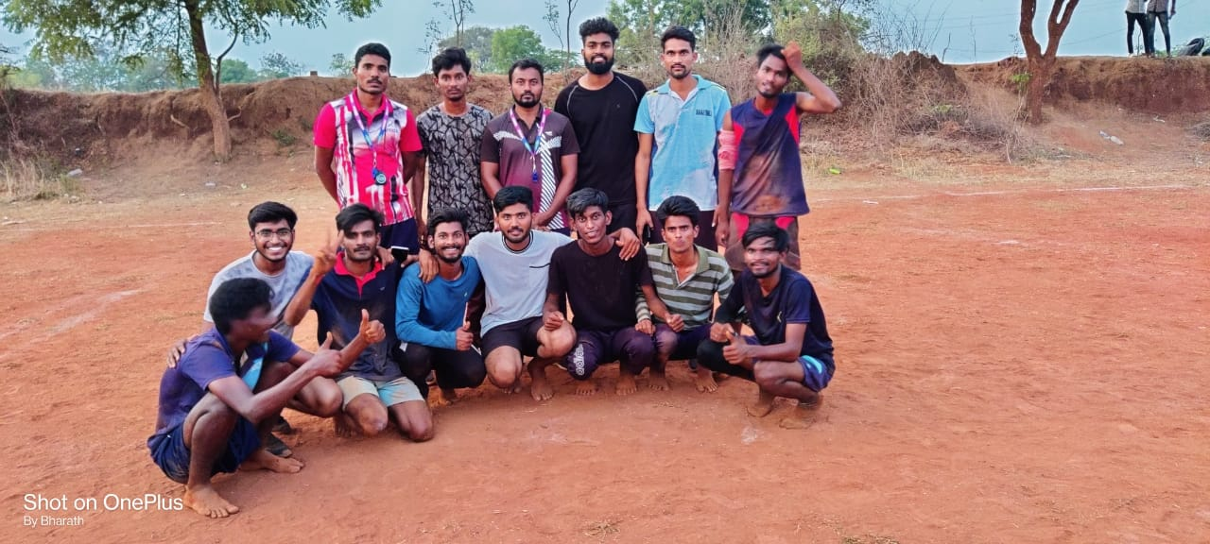
Intramural games April, 2022 Kho-Kho, Boys

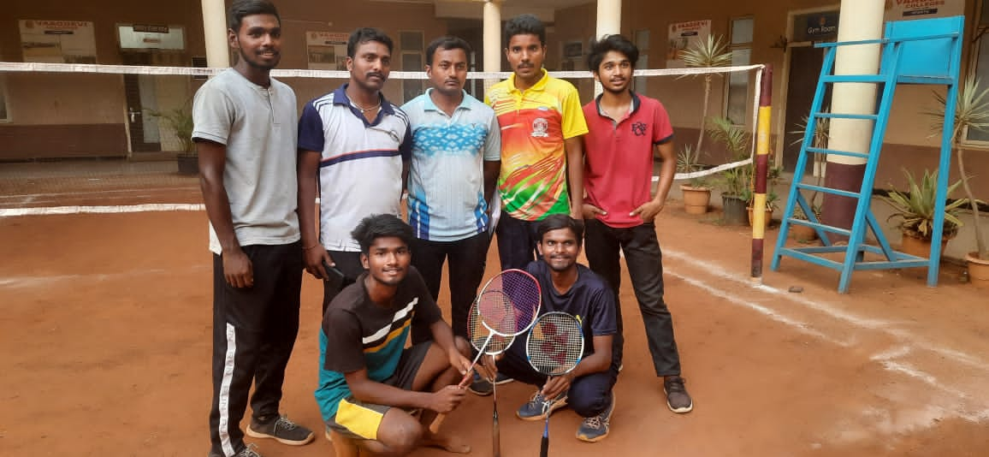
Intramural games April, 2022 Badminton, Doubles-Boys

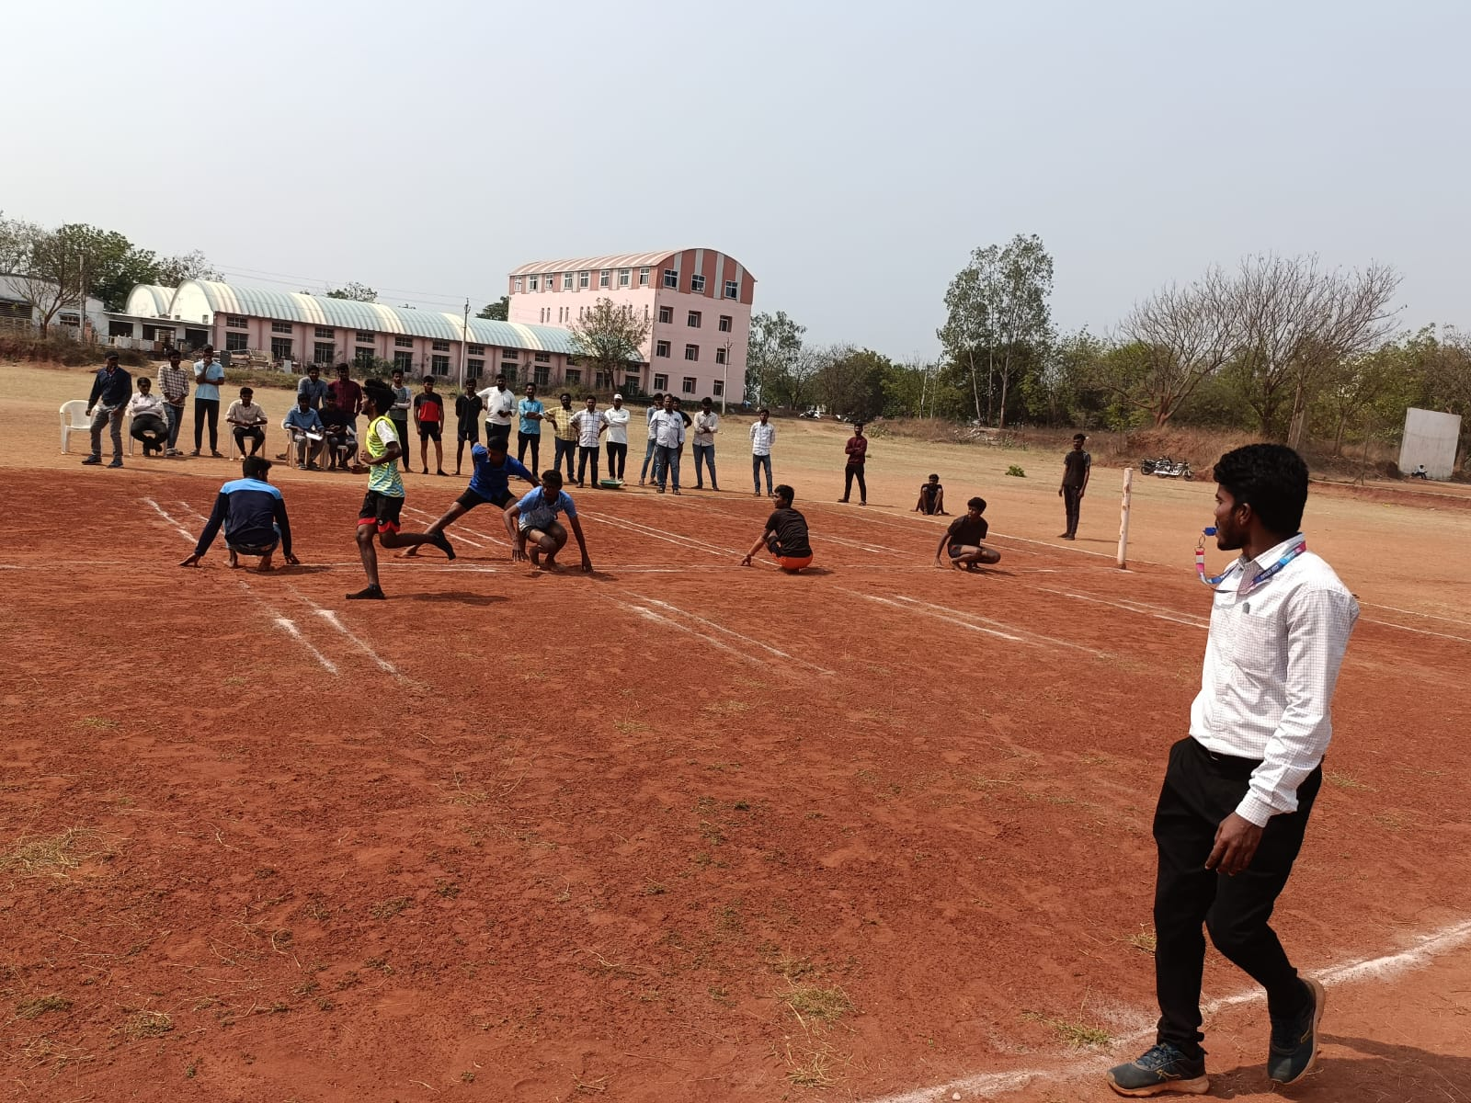

Intramural games April, 2022 Kho-Kho

VAAGDEVI COLLEGE OF ENGINEERING

VAAGKREEDA ‘2019-2020’

RUNS
400 X 100 REALY
3rd Place: CIVIL
2nd Place: CSE
1st Place: MECHANICAL
100 mtr Boys
3rd Place: N. Pavan Sai EEE
2nd Place: G. Nikhil CSE
1st Place: G. Kalyan MECH

100 mts GIRLS
3rd Place: B. Pravalika CIVIL
2nd Place: S. Athira EEE
1st Place: B. Swathi MECH
200 mts BOYS
3rd Place: P. Steeva CSE
2nd Place: Venkatesh MECH
1st Place: G. Kalyan MECH
200 mts GIRLS
3rd Place: M. Sravanthi CSE
2nd Place: Athira EEE
1st Place: P. Sai Priya CSE
400 mtr BOYS
3rd Place: Anil Nayak CIVIL
2nd Place: P. Steeva CSE
1st Place: Venkatesh MECH

400 mtr GIRLS
3rd Place: G. Pravalika EEE
2nd Place: G. Venkatesh EEE
1st Place: B. Swathi MECH

VAAGDEVI COLLEGE OF ENGINEERING
VAAGKREEDA ‘2019-2020’
THROWS
JAVELIN THROW BOYS:
3RD PLACE: T. ANIL NAYAK CIVIL
2ND PLACE: P. STEEVA CSE
1ST PLACE: S. SHISVJI EEE
JAVELIN THROW GIRLS:
3RD PLACE: D. AKHILA CIVIL
2ND PLACE: B. PRAVALIKA CIVIL
1ST PLACE: S. ATHIRA EEE
DISCUS THROW BOYS:
3RD PLACE: G. HARI KUMAR CIVIL
2ND PLACE: N. HARIHARAN CIVIL
1ST PLACE: K. YAGNESHWAR EEE
SHOTPUT GIRLS:
3RD PLACE: D. AKHILA CIVIL
2ND PLACE: B. PRAVALIKA CIVIL
1ST PLACE: S. ATHIRA EEE
SHOTPUT BOYS:
3RD PLACE: G. KALYAN MECH
2ND PLACE: S. SHIVAJI EEE
3RD PLACE: K. YAGNESHWAR EEE
LONGJUMP BOYS:
3RD PLACE: P. STEEVA CSE
2ND PLACE: G NIKHIL CSE
1ST PLACE: G. KALYAN KUMAR MECH
VAAGDEVI COLLEGE OF ENGINEERING
VAAGKREEDA ‘2019-2020’

BADMINTON: SINGLES (BOYS)
RUNNERS: B. KARTHIKEYA CSE
WINNERS: G. NIKHIL CSE
BADMINTON: SINGLES (GIRLS)
RUNNERS: K. MANISHA CSE
WINNERS: V. CHAITHANYA CSE
BADMINTON: DOUBLES (MEN)
RUNNERS: SRINADH MECH
NITHIN MECH
WINNERS: G. NIKHIL CSE
P. STEEVA CSE
BADMINTON: DOUBLES (GIRLS)
RUNNERS: B. SOUMYA SRI CSE
CH. SATHVIKA CSE
WINNERS: V. CHAITHANYA CSE
B. NAVYA SRI CSE
BADMINTON: MIXED DOUBLES
RUNNERS: G. NIKHIL CSE
CH. SATHVIKA CSE
WINNERS: P. STEEVA CSE
V. CHAITHANYA CSE

VAAGDEVI COLLEGE OF ENGINEERING
VAAGKREEDA ‘2019-2020’

CARROM: SINGLES: BOYS
RUNNER: G. THIRUPATHI REDDY CSE
WINNER: MD. SOHAL EEE
CARROM: SINGLES: GIRLS
RUNNER: K. SAISHMA CSE
WINNER: O. AKSHARA REDDY ECE
CARROM: DOUBLES: BOYS
RUNNERS: T. RITHISH
M. SHUSHANK ECE
WINNERS: G. VIKAS
CH. PAVAN EEE
CARROM: DOUBLES: GIRLS
RUNNERS: P. TEJASWINI
S. GAYATHRI ECE
WINNERS: CH. TEJASWINI
S. ATHIRA ECE
CHESS: BOYS
RUNNERS: V. VISHNU TEJA CSE
WINNERS: N. SRIHARSHA VIKAS CSM
CHESS: GIRLS
RUNNER: A. VARSHITHA ECE
WINNER: P. TEJASWINI ECE

VAAGDEVI COLLEGE OF ENGINEERING
VAAGKREEDA ‘2019-2020’

VOLLEYBALL: BOYS
RUNNER: MECH
WINNER: ECE
THROW BALL: GIRLS
RUNNER: CSE
WINNER: CIVIL
KHO-KHO: BOYS
RUNNER: ECE
WINNER: CSE
KHO-KHO: GIRLS
RUNNER: ECE
WINNER: CSE
KABADDI: BOYS
RUNNER: EEE
WINNER: MECH
KABADDI: GIRLS
RUNNER: ECE
WINNER: CIVIL
CRICKET: BOYS
RUNNER: CIVIL
WINNER: EEE
Basket Ball: BOYS
RUNNER: CIVIL
WINNER: CSE
VAAGDEVI COLLEGE OF ENGINEERING
Bollikunta, Warangal, Telangana

- Game Secretary for boys: Md. Sameer – EEE
- Game secretary for girls: B. Pravalika – Civil
- Sports secretary for boys: Srinadh-mech
- Sports Secretary for girls: V. Chaithanya-CSE

- Cricket captain: Sai Kushal – Civil
- Kabaddi captain: Darmateja – Civil
- Volley ball Captain: Akshay – Mech
- Kho-Kho Captain: P. Steeva – CSE

Physical Director Department Of Physical Education Principal

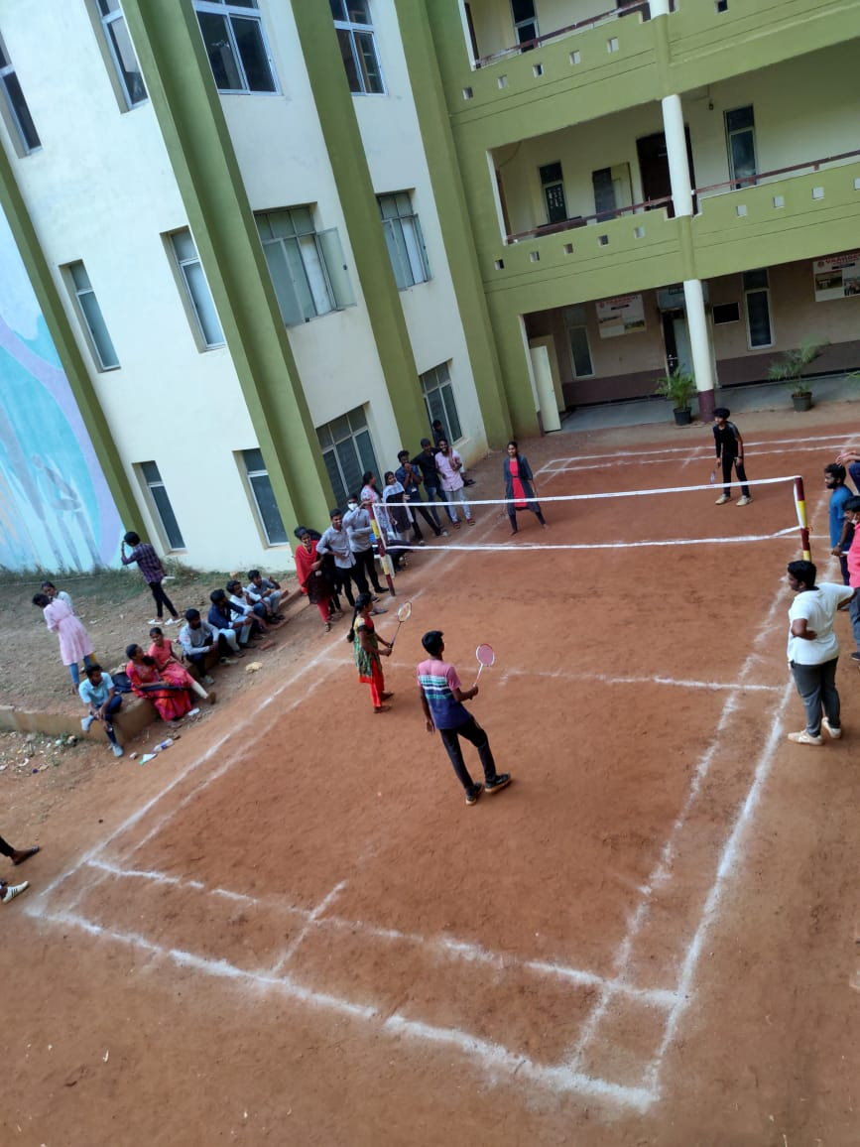
Intramurals 2019-2020 Badminton, Mixed-Doubles

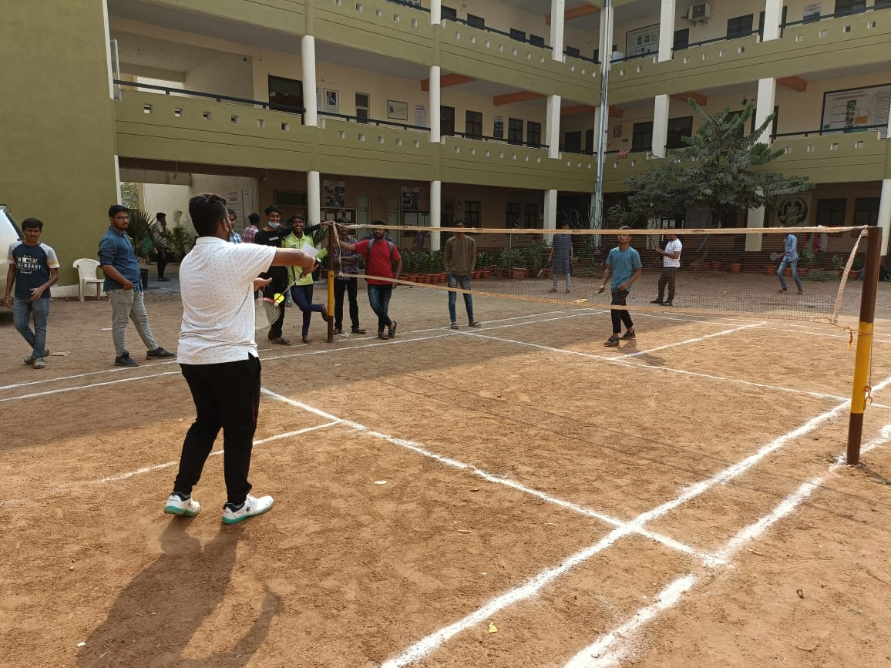

Intramurals 2019-2020 Badminton, Boys Singles

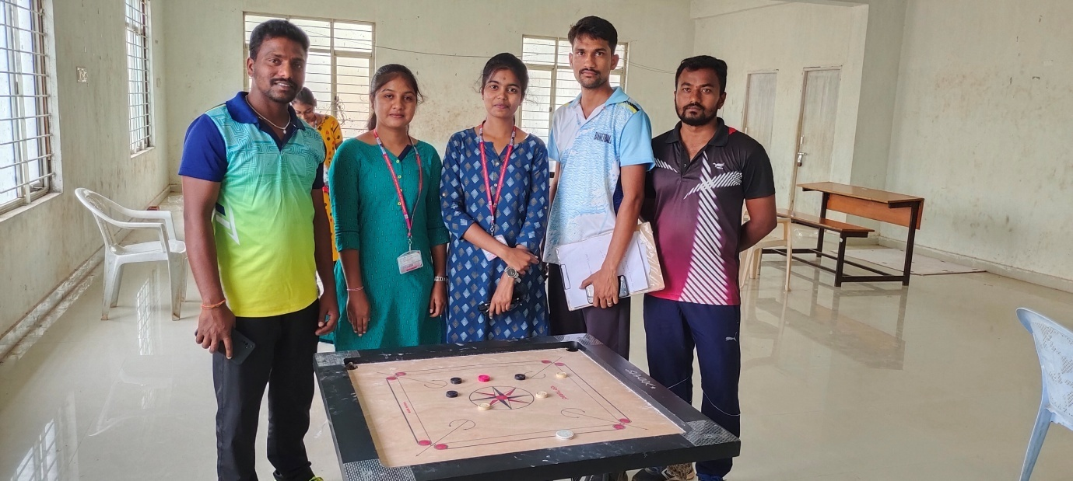
Intramurals 2019-2020 Carrom, Doubles Girls

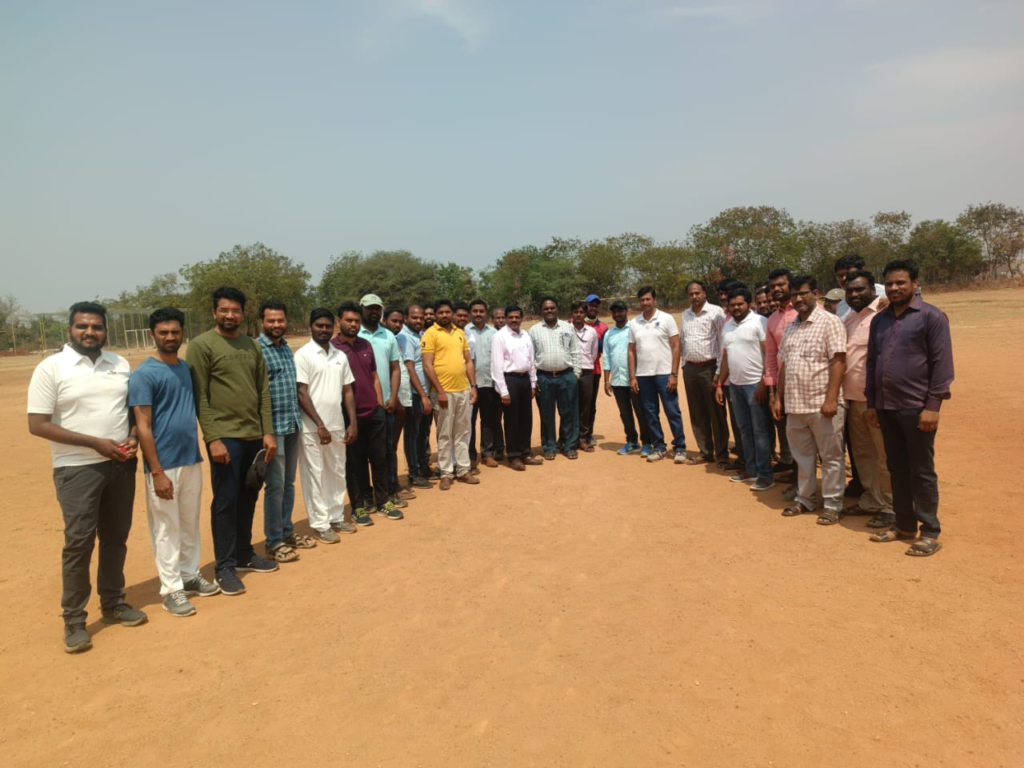
Intramurals 2019-2020 Staff Cricket Tournament
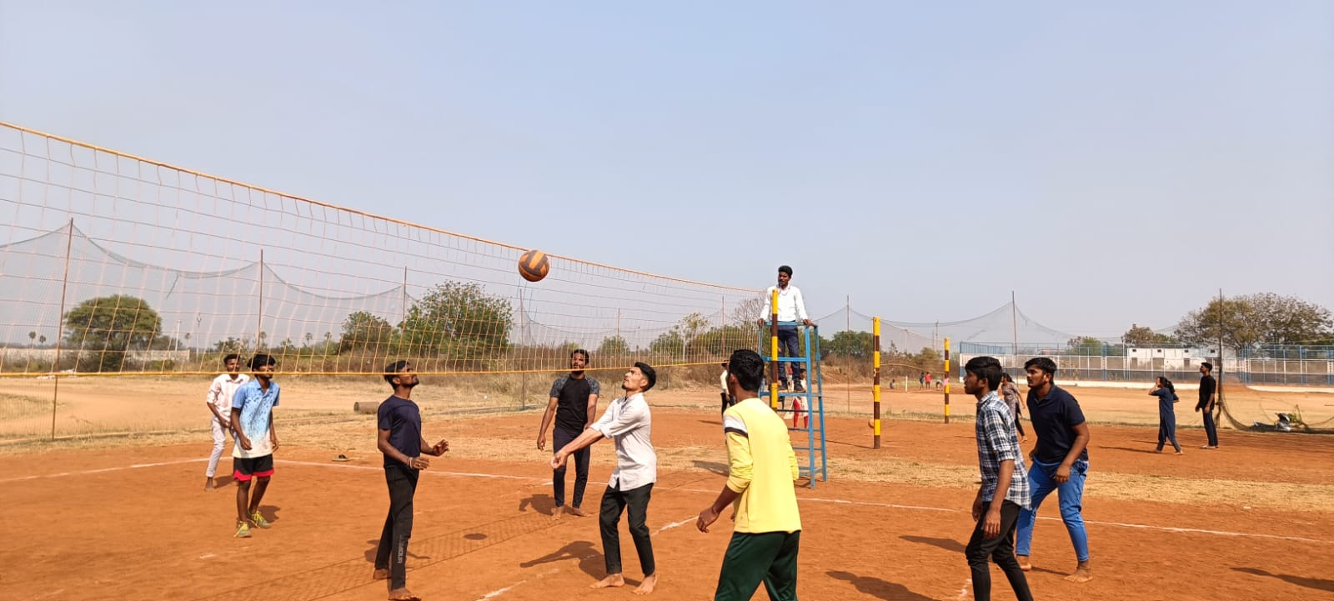
Intramurals 2019-2020 Volley Ball, Boys

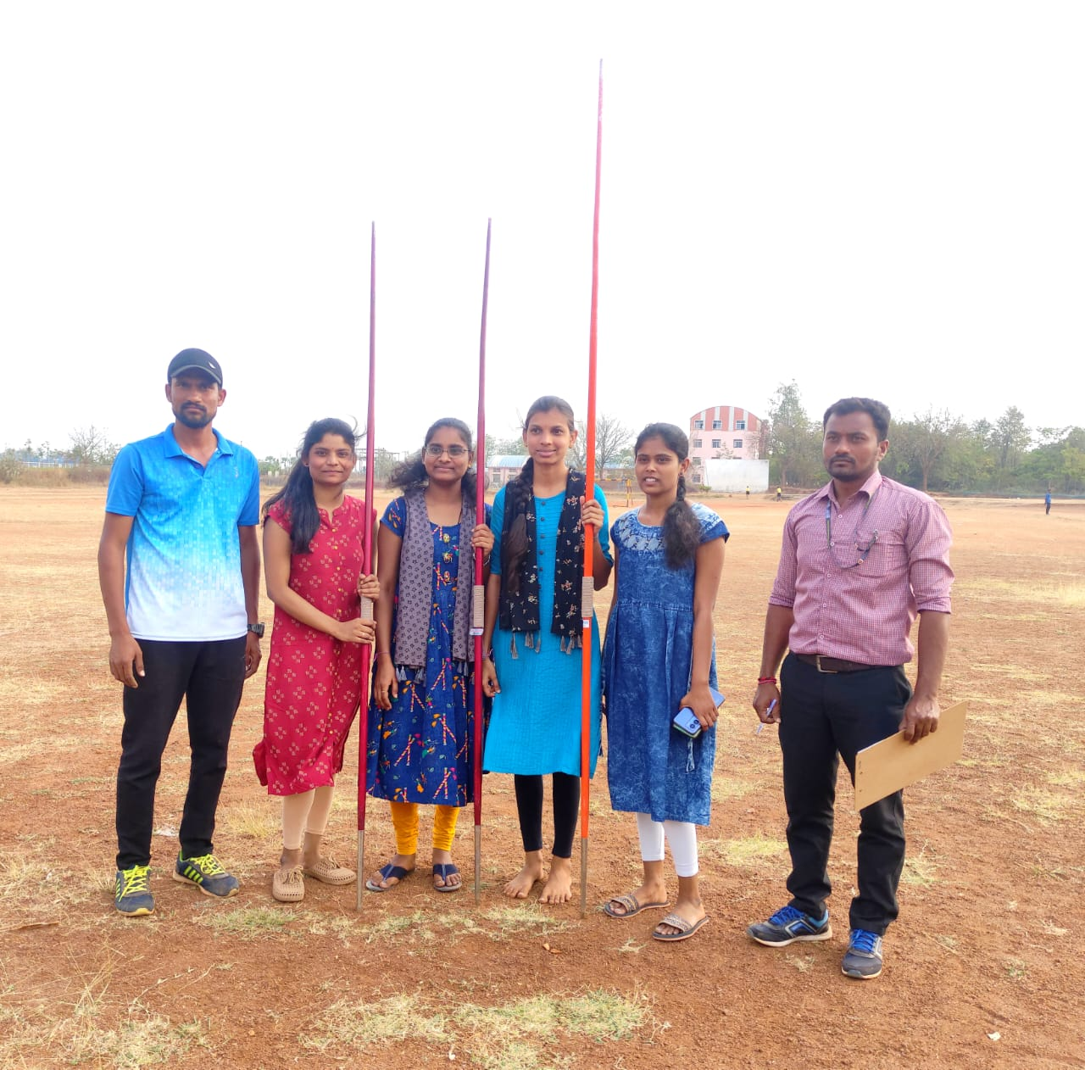
Intramurals 2019-2020 Javelin Throw Girls 1st , 2nd , 3rd places

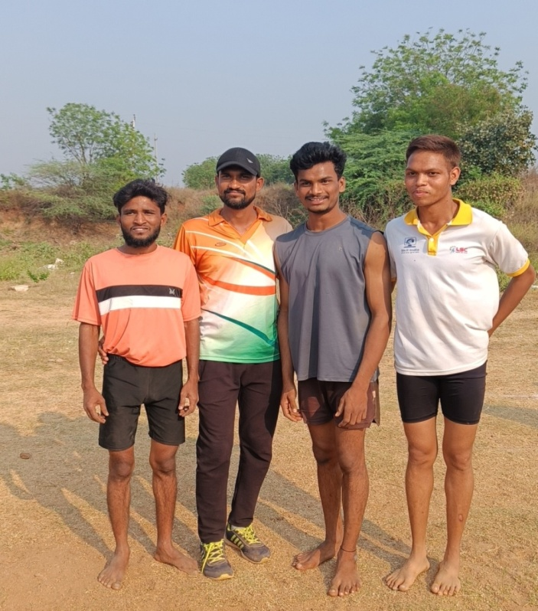
Intramurals 2019-2020 Running Event
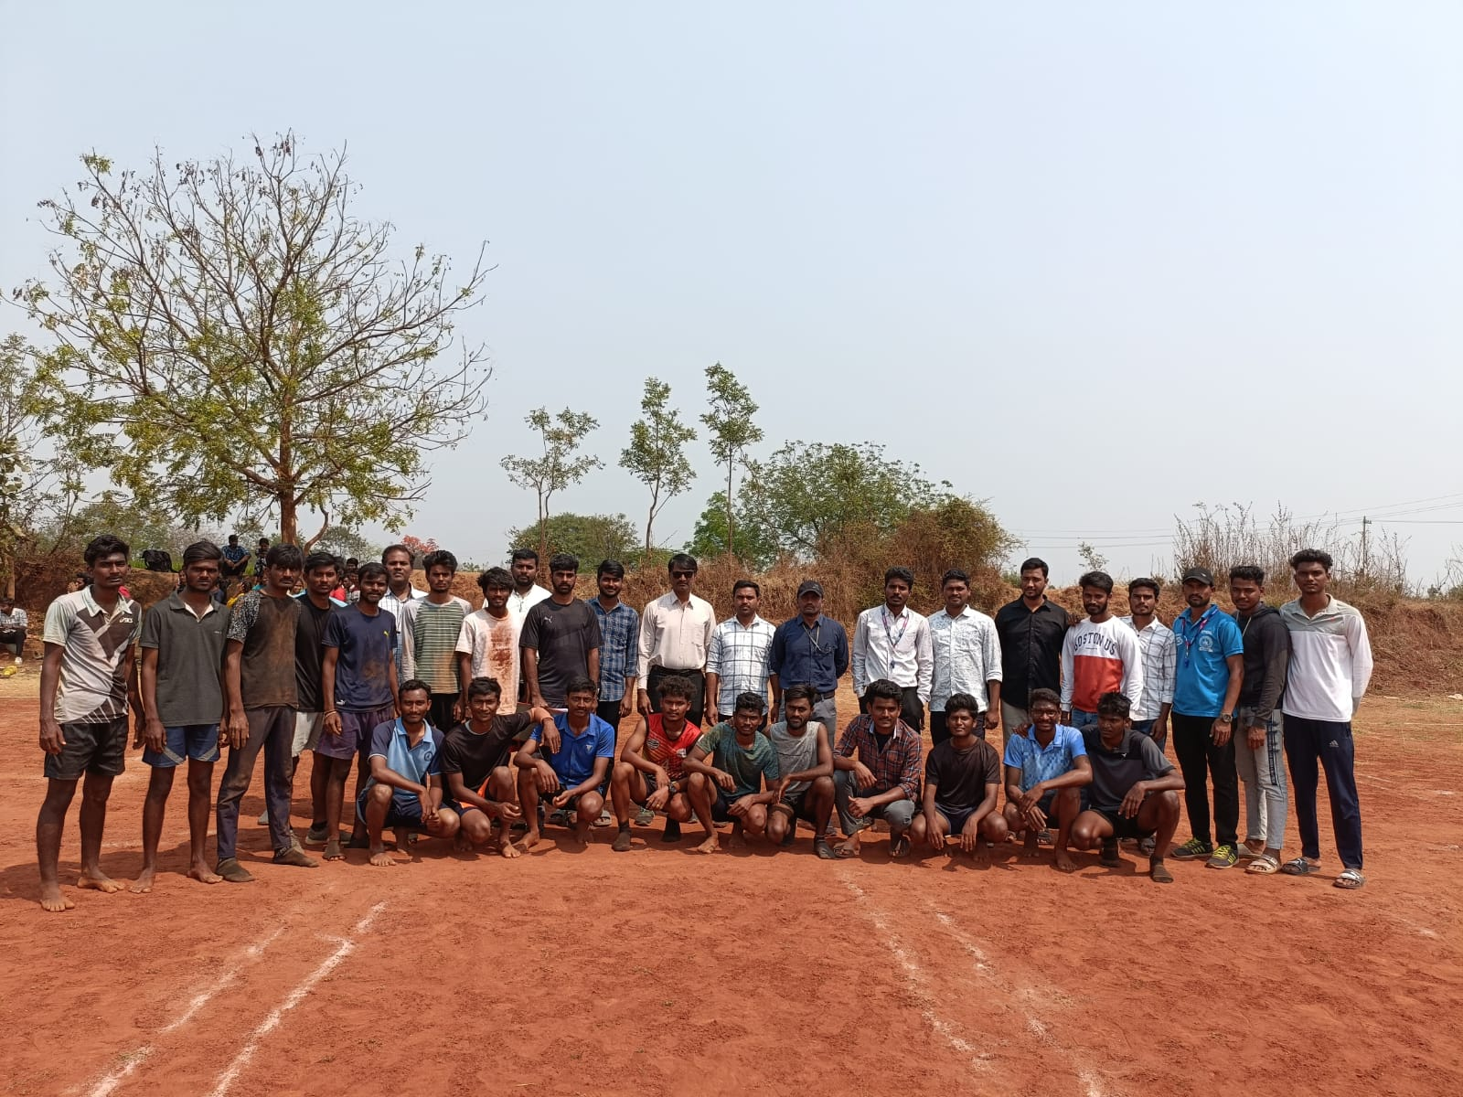
Intramurals 2019-2020 Kho-Kho, Boys

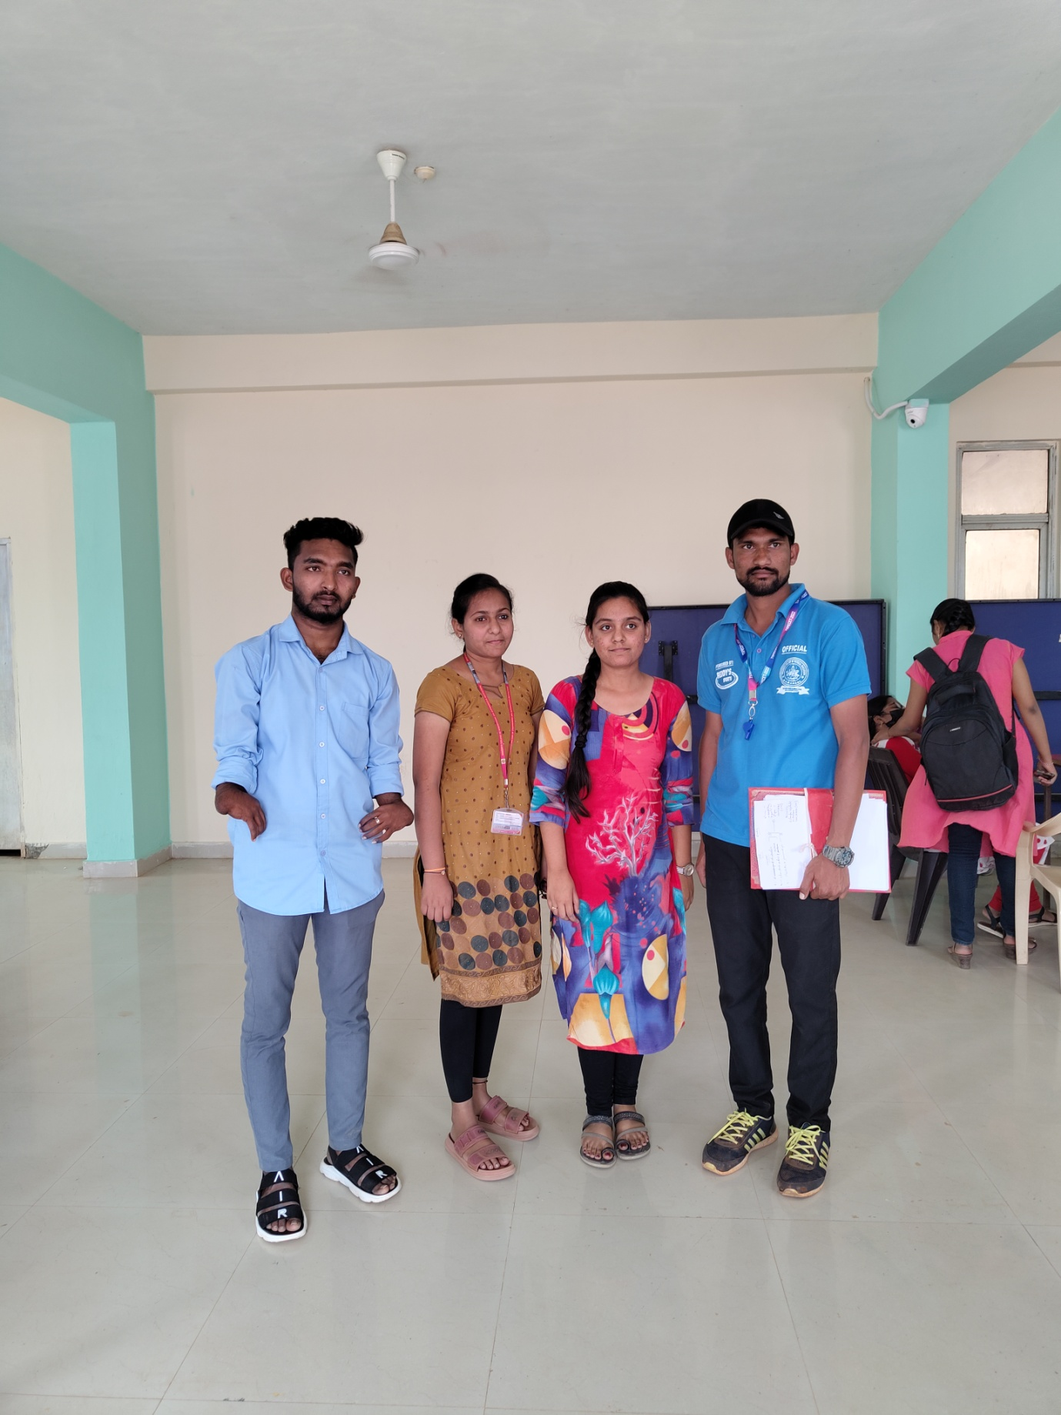
Intramurals 2019-2020 Carrom, Doubles

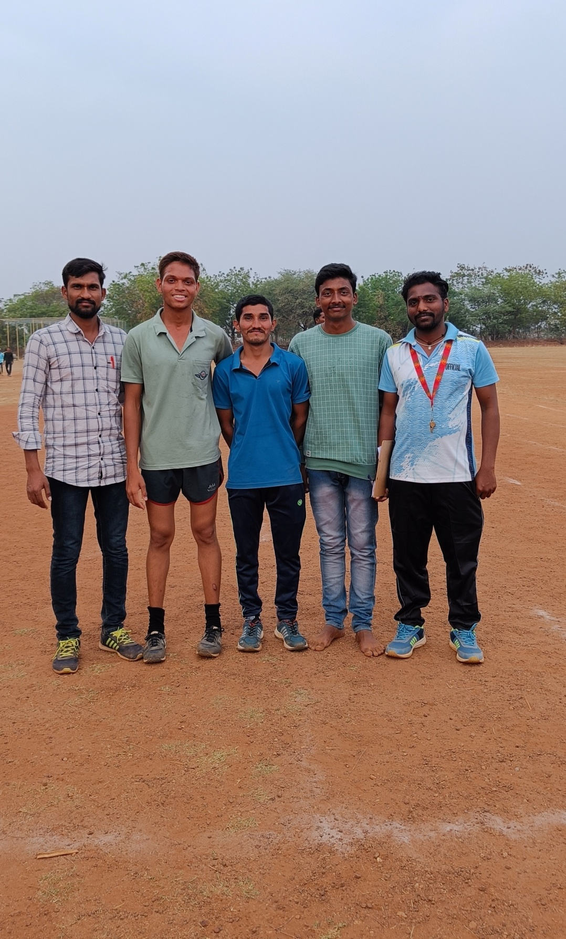
Intramurals 2019-2020 Running Events

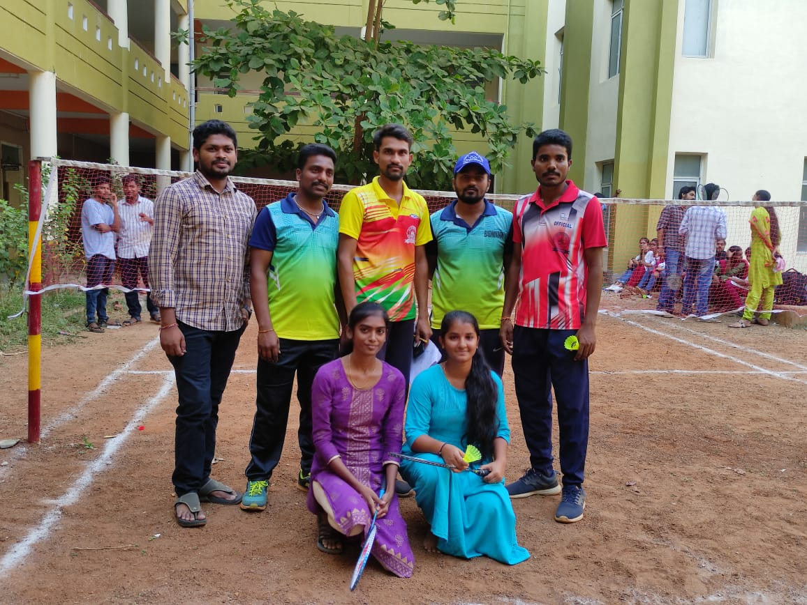
Intramurals 2019-2020 Badminton Doubles-Girls
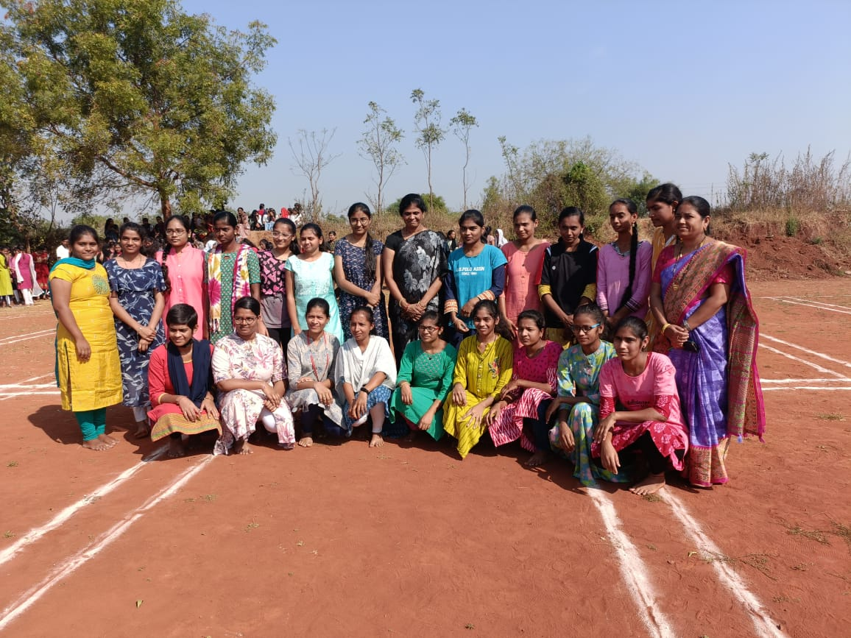
Intramurals 2019-2020 Kho-Kho, Girls

